Nutraceutical and Pharmaceutical Applications of Hive Products

Submitted By
CHANDRAGEEDHANI C

Submitted for the fulfilment of
Three-Days National Training Program
Beekeeping Entrepreneurship

Organized By: Meadow Agriculture

Date of submission :14.03.2026
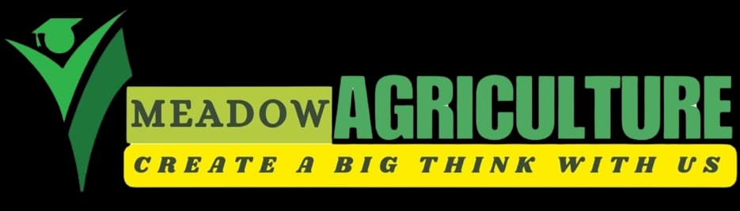

Nutraceutical and Pharmaceutical Applications of Hive Products
A detailed narrative review
Prepared in detailed review format with paragraph-end author–year citations and Vancouver references
■ ■ ■
Abstract
Hive products have moved from traditional apitherapy to the modern spaces of nutraceutical design, wound management, oral care, drug delivery, regenerative medicine and adjunct pharmacology. Honey, propolis, royal jelly, bee pollen, bee bread, bee venom and beeswax contain chemically diverse molecules, including sugars, organic acids, flavonoids, phenolic acids, proteins, peptides, fatty acids, enzymes, terpenoids and wax esters, which collectively support antioxidant, antimicrobial, anti-inflammatory, immunomodulatory, tissue-regenerative and, in selected models, antitumor effects. This review synthesizes current evidence on the composition, mechanisms, formulation science, clinical and preclinical applications, safety concerns and translational barriers associated with hive products. Particular emphasis is placed on their dual identity: as nutraceuticals used in health maintenance and functional foods, and as pharmaceutical or biomedical agents used in dressings, gels, ointments, oral-care formulations, nano-systems, scaffolds, adjuvant therapies and targeted bioactive platforms. Honey remains the most mature product for topical wound care, while propolis and royal jelly have broad potential in oral health, inflammatory disorders and metabolic support. Bee pollen and bee bread are primarily positioned as functional-food ingredients but increasingly attract attention for anti-inflammatory, antimicrobial and antioxidant applications. Bee venom, driven by melittin and related peptides, represents the most pharmacologically potent yet safety-limited hive product, with ongoing interest in cancer, pain, arthritis and nanomedicine. Beeswax, although less discussed as a therapeutic bioactive, is highly valuable as a natural excipient, barrier-former, emollient and drug-delivery material. Across all products, the major barriers to wider medical translation are source variability, insufficient standardization, allergenicity, dose uncertainty, contamination and the persistent gap between promising preclinical data and robust randomized human evidence. The review concludes that hive products are best viewed as a continuum ranging from traditional nutraceuticals to modern bioactive pharmaceutical platforms, but their responsible integration into healthcare requires standardized characterization, stronger clinical evidence and fit-for-purpose formulation strategies (Pasupuleti et al., 2017; El-Seedi et al., 2022; El-Didamony et al., 2024).
Keywords: Apitherapy; honey; propolis; royal jelly; bee pollen; bee bread; bee venom; beeswax; nutraceuticals; pharmaceuticals; wound healing; oral health
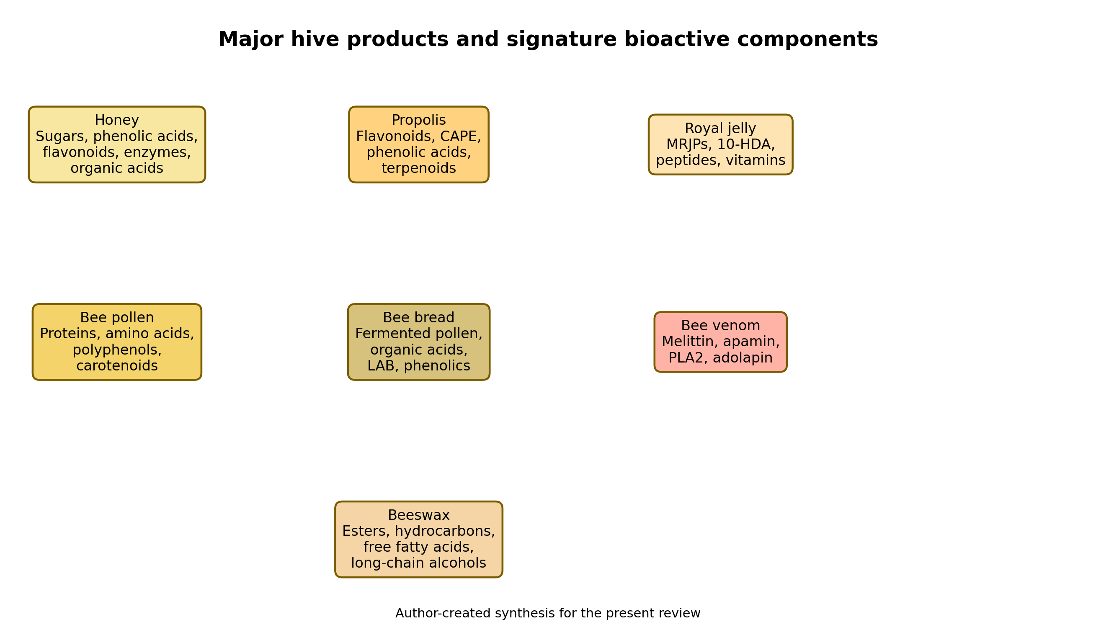
Figure 1. Major hive products and their signature bioactive components. Author-created synthesis for the present review.

1. Introduction
The term hive products refers to the spectrum of natural materials collected, transformed or secreted by honeybees, principally honey, propolis, royal jelly, bee pollen, bee bread, bee venom and beeswax. For centuries these products have occupied a hybrid position between food, folk medicine and ritual material, but contemporary research increasingly frames them as reservoirs of bioactive molecules that can be developed into functional foods, nutraceuticals, topical medicines, oral-care agents, biomaterials and drug-delivery systems. This growing interest reflects a broader shift in biomedicine toward complex natural products that can provide multitarget effects, especially antimicrobial, anti-inflammatory and antioxidant actions that are difficult to reproduce with single-molecule therapies alone (Pasupuleti et al., 2017; El-Seedi et al., 2022; Sanlier et al., 2026).
Unlike many plant-derived products that enter human use after a relatively direct harvesting process, hive products are biologically edited materials. Honey is nectar transformed by enzymatic action and dehydration; propolis is a plant resin modified with waxes and salivary enzymes; bee bread is fermented pollen preserved within comb cells; royal jelly and beeswax are secretions of worker bees; and bee venom is a defensive biochemical cocktail delivered by the sting apparatus. This biological processing gives hive products distinctive chemical architectures and explains why they often possess multiple overlapping activities rather than a single dominant pharmacological effect (El-Didamony et al., 2024; Ali and Kunugi, 2020; Kurek-Górecka et al., 2020).
The modern scientific interest in hive products is driven by several converging factors. First, antimicrobial resistance has renewed attention to complex natural antimicrobials such as honey and propolis. Second, the global burden of chronic inflammatory and metabolic diseases has stimulated exploration of antioxidant and immunomodulatory nutraceuticals. Third, advances in biomaterials and nanotechnology now allow challenging agents such as melittin or propolis extracts to be incorporated into carriers that may improve selectivity, stability and tolerability. Finally, consumer demand strongly favours natural-origin health products, which has accelerated the commercial translation of hive-derived ingredients into supplements, dressings, cosmetics, oral-care products and functional beverages (Zullkiflee et al., 2022; Sadek et al., 2024; Zainuddin et al., 2025).
At the same time, enthusiasm for hive products must be balanced with scientific caution. Chemical composition varies with bee species, botanical source, geography, season, processing and storage; clinical data remain uneven across products; and adverse reactions, particularly allergy and contamination, are non-trivial. Therefore, a meaningful review must move beyond celebratory language and examine not only bioactivity but also formulation issues, evidence quality, safety, standardization and regulatory translation. The present review adopts that broader perspective and evaluates hive products as a continuum from nutraceutical support to pharmaceutical application (Pasupuleti et al., 2017; Kumar et al., 2024; Nong et al., 2023).

2. Review approach and scope
This article is a narrative review that integrates broad review literature, systematic reviews, selected preclinical syntheses and translational papers focusing on the major hive products and their health-related uses. The scope includes composition, mechanisms of action, nutraceutical applications, pharmaceutical and biomedical applications, formulation strategies, safety, standardization and future prospects. Because the literature on hive products is vast and heterogeneous, emphasis is placed on high-yield sources that synthesize evidence across disease categories or product classes, while representative clinical and translational examples are used where necessary to show how bench findings are being moved toward applied use (Pasupuleti et al., 2017; El-Seedi et al., 2022; Kumar et al., 2024).
The term nutraceutical is used here to describe hive products employed as functional foods, dietary supplements or adjunctive health-promoting ingredients intended to support physiology or reduce disease risk. The term pharmaceutical is used in a broader translational sense to include medicinal dressings, gels, hydrogels, mouthwashes, ointments, scaffolds, controlled-release systems, targeted delivery platforms and bioactive formulations developed for prevention or treatment. This distinction is important because the same product may move between categories depending on dose, processing, evidence base, indication and route of administration; honey, for example, can be consumed as a food, marketed as a supplement, or standardized as medical-grade wound dressing material (Tashkandi et al., 2021; Chrysostomou et al., 2024; Zainuddin et al., 2025).

3. Classification of hive products and determinants of composition
Hive products can be divided into collected products and secreted products. Honey, propolis, bee pollen and bee bread originate primarily from plant-derived materials that are collected and subsequently modified by bees, whereas royal jelly, beeswax and bee venom are secretory products synthesized by specialized bee glands. This classification is not merely descriptive; it has direct implications for chemistry and standardization. Collected products show strong botanical and geographic signatures, while secreted products tend to be more biologically conserved but still vary with colony health, season, bee age and handling. The end result is that every hive product exists as a family of related chemotypes rather than a single chemically fixed entity (El-Didamony et al., 2024; Baky et al., 2023; Oršolić and Jazvinšćak Jembrek, 2024).
The main determinants of hive-product composition are floral source, climate, geographical region, bee species, soil chemistry, environmental pollution, harvest method, extraction solvent and storage conditions. For instance, propolis from temperate zones is often rich in poplar-derived flavonoids and phenolic esters, while tropical propolis may contain prenylated compounds or terpenoids from different plant resins. Likewise, the phenolic profile of honey or pollen may differ substantially between monofloral and multifloral sources. These compositional shifts matter because they influence antimicrobial strength, antioxidant capacity, sensory properties and even safety profiles, which in turn affect how products can be positioned as supplements or medicines (Zullkiflee et al., 2022; Thakur and Nanda, 2020; Bakour et al., 2022).
A second critical determinant is processing. Raw honey may retain enzymes and volatile fractions that are partly lost upon heating; ethanolic extracts of propolis concentrate lipophilic phenolics differently from aqueous extracts; fermentation transforms pollen into bee bread with altered digestibility and microbial profile; and protease treatment of royal jelly can reduce allergenicity while changing protein composition. Therefore, the idea that a hive product has a single fixed activity is misleading. What often shows activity is not the raw source alone but a defined preparation, with its own extraction chemistry, concentration and delivery form (Ali and Kunugi, 2020; El Ghouizi et al., 2023; El-Seedi et al., 2022).

Table 1. Overview of major hive products, dominant constituents and translational niches.
Product | Origin | Signature constituents | Main current application niche
Honey | Collected and bee-processed nectar | Sugars, enzymes, phenolics, organic acids | Functional food; wound dressings; mucosal support
Propolis | Plant resins + wax + bee enzymes | Flavonoids, CAPE, phenolic acids, terpenoids | Oral care; anti-inflammatory adjuncts; wound formulations
Royal jelly | Secreted by nurse bees | MRJPs, 10-HDA, peptides, vitamins | Healthy aging supplements; mucosal and inflammatory support
Bee pollen | Flower pollen loads | Proteins, amino acids, polyphenols, carotenoids | Nutrient-dense supplements; antioxidant support
Bee bread | Fermented stored pollen | Phenolics, proteins, organic acids, LAB-associated metabolites | Fermented functional foods; supportive extracts
Bee venom | Defensive venom secretion | Melittin, apamin, PLA2, adolapin | Pain/inflammation research; oncology and nanomedicine
Beeswax | Wax-gland secretion | Esters, hydrocarbons, fatty acids, alcohols | Ointments, films, semisolids, release-modifying excipient
Source: author synthesis based on the reviewed literature (El-Didamony et al., 2024; El-Seedi et al., 2022; Pasupuleti et al., 2017).

4. Major bioactive classes and shared mechanisms
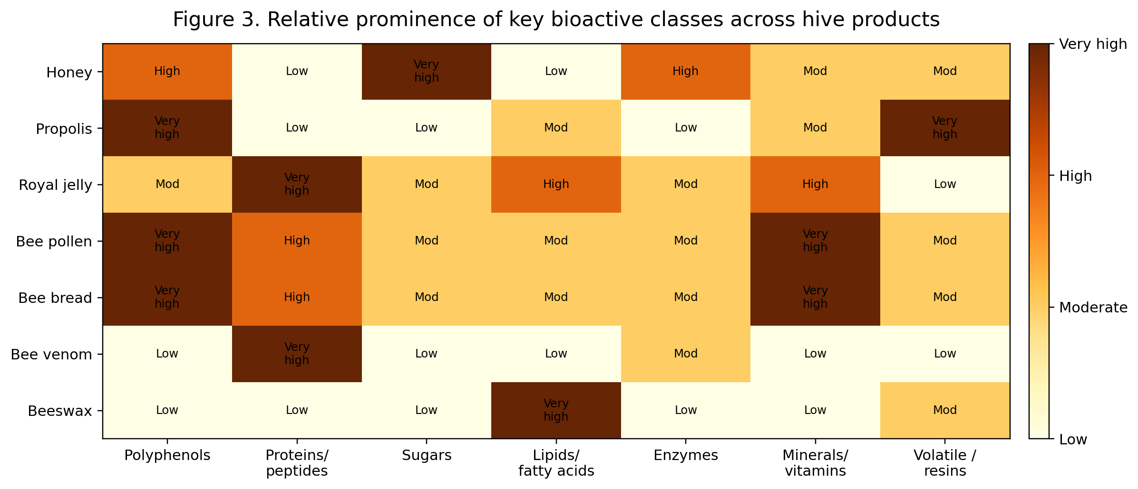
Figure 3. Relative prominence of key bioactive classes across hive products.
Despite their diversity, hive products share several recurring bioactive themes. Polyphenols, including flavonoids and phenolic acids, are especially prominent in honey, propolis, bee pollen and bee bread. Proteins and peptides dominate royal jelly and bee venom, with major royal jelly proteins, melittin and apamin being particularly important. Organic acids, simple sugars, enzymes, vitamins, minerals, terpenoids, fatty acids and wax esters provide additional layers of activity. These molecular classes underpin the broad pharmacological patterns repeatedly described in the literature: antioxidant, antimicrobial, anti-inflammatory, immunomodulatory, metabolic-regulatory, wound-healing and, in selected settings, anticancer effects (Pasupuleti et al., 2017; El-Seedi et al., 2022; Oršolić and Jazvinšćak Jembrek, 2024).
Across the reviewed products, several mechanistic pathways recur. First, many hive products reduce oxidative stress by scavenging reactive oxygen species or upregulating endogenous antioxidant defenses. Second, they modulate inflammatory signalling, particularly NF-κB, MAPK, COX-2, iNOS, TNF-α and interleukin pathways. Third, they exert antimicrobial effects through osmotic stress, membrane disruption, inhibition of biofilm formation, low pH, hydrogen peroxide generation or direct peptide-mediated cytolysis. Fourth, some components promote tissue repair through moisture balance, angiogenesis support, fibroblast migration, extracellular matrix modulation and epithelial regeneration. Fifth, selected molecules such as caffeic acid phenethyl ester (CAPE), 10-HDA or melittin also influence apoptosis, mitochondrial signalling and cell-cycle machinery, opening the door to oncology-related applications (Zullkiflee et al., 2022; Tashkandi et al., 2021; Gajski et al., 2024).
These shared mechanisms partly explain why hive products are rarely confined to one disease area. A single product such as propolis can be studied in oral infections, metabolic syndrome, inflammatory bowel models and cancer systems because the underlying pathways—oxidative stress, inflammation and microbial dysbiosis—overlap across diseases. This pleiotropy is attractive from a translational perspective, but it also creates a challenge: broad mechanistic promise does not automatically translate into clinically meaningful benefit for a specific indication. The future of hive-product research therefore depends on narrowing from generic bioactivity to indication-specific, formulation-specific, dose-specific evidence (Chavda et al., 2023; El-Seedi et al., 2022; Sadek et al., 2024).

5. Honey: composition and nutraceutical profile
Honey is the most widely consumed and clinically mature hive product. Chemically, it is a supersaturated solution dominated by fructose and glucose but enriched by amino acids, organic acids, vitamins, minerals, enzymes, flavonoids and volatile compounds. Its low water activity, acidity, peroxide-generating capacity and complex phytochemical content account for many of its biological effects. Nutraceutically, honey functions as more than a sweetener: it is positioned as a rapidly available energy source, a matrix for bioactive phenolics and a traditionally accepted adjunct for gastrointestinal and respiratory comfort. The exact biological strength of a given honey, however, depends heavily on floral source and processing conditions (Pasupuleti et al., 2017; Tashkandi et al., 2021; Iosageanu et al., 2024).
From a nutritional standpoint, honey offers a readily absorbable carbohydrate source with a phytochemical profile that may support antioxidant defense and microbial control. Although it should not be romanticized as a low-sugar miracle food, its matrix differs meaningfully from refined sugar because of the presence of minor bioactive compounds and enzymes. In functional-food contexts, honey is often explored as a carrier for plant extracts, probiotics, herbal ingredients and fermented beverages, and it can improve palatability and preservation while contributing its own mild antimicrobial and soothing properties. Such positioning explains its enduring use in cough syrups, herbal suspensions and restorative tonics (Pasupuleti et al., 2017; El-Didamony et al., 2024; Chrysostomou et al., 2024).
The strongest nutraceutical rationale for honey lies in mucosal soothing, cough support, gastrointestinal comfort and general antioxidant supplementation. Its osmotic and prebiotic-like effects may favour gut ecology in certain contexts, and its pleasant sensory profile makes it a highly acceptable vehicle for pediatric and adult support products. Nevertheless, because honey remains carbohydrate-rich, claims around metabolic health must be tempered and individualized, especially in diabetes care. The literature supports cautious functional use rather than uncritical consumption under the assumption that all honey is inherently medicinal (Pasupuleti et al., 2017; Tashkandi et al., 2021).

6. Honey as a pharmaceutical and biomedical agent
The most convincing pharmaceutical application of honey is in topical wound care. Medical-grade honey has demonstrated relevance in acute wounds, burns, ulcers and infected postoperative wounds because it provides a moist healing environment while simultaneously suppressing microbial growth and reducing malodor. Its high osmolarity draws fluid from tissues and microbes, hydrogen peroxide contributes antimicrobial action in many honeys, and phenolic components may help modulate inflammation and oxidative burden. Importantly, honey is not merely an antiseptic coating; it acts as a multifunctional wound microenvironment modifier (Tashkandi et al., 2021; Tang et al., 2024; Chrysostomou et al., 2024).
Recent reviews have also highlighted the transition from crude honey application to engineered dressings, especially honey-containing hydrogels, films and composite biomaterials. These systems aim to preserve the wound-healing value of honey while improving viscosity, retention at the wound site, controlled release and ease of dressing change. Hydrogel integration is especially attractive because it addresses practical limitations of raw honey, including leakage and inconsistent dosing, while leveraging honey's antimicrobial and anti-inflammatory properties within a modern biomaterials platform. Such formulations exemplify how a traditional natural remedy can be rationally upgraded into a pharmaceutical-grade delivery system (Zainuddin et al., 2025; Rawwash et al., 2025; Iosageanu et al., 2024).
Beyond skin wounds, honey has been studied in oral mucositis, oral ulcers and supportive mucosal care during cancer therapy. Reviews in oral medicine suggest that honey and, in some settings, propolis can reduce severity and pain in therapy-induced oral mucositis and improve mucosal recovery, although heterogeneity in protocols remains substantial. This makes honey one of the rare hive products with repeated signals across both soft-tissue wound healing and oral supportive care. Even so, product standardization and well-designed randomized trials remain necessary before general therapeutic claims can be universalized (Münstedt and Männle, 2019; Choudhary et al., 2023; Tashkandi et al., 2021).

7. Propolis: chemistry and broad therapeutic logic
Propolis is a resinous material that bees produce from plant exudates mixed with wax and salivary components, and it is among the most chemically rich hive products. It contains flavonoids, phenolic acids, phenolic esters such as CAPE, aromatic aldehydes, terpenoids and numerous minor constituents whose proportions vary with botanical origin. Because of this chemistry, propolis is often described as the most pharmacologically versatile hive product after bee venom, but with a much better practical safety and formulation profile. Its reputation as a 'bee glue' for hive defense mirrors its biological role in human applications: antimicrobial barrier, anti-inflammatory modulator and antioxidant protector (Zullkiflee et al., 2022; Chavda et al., 2023; El-Seedi et al., 2022).
The pharmaceutical interest in propolis rests largely on its multitarget behaviour. CAPE, pinocembrin, galangin, chrysin and related molecules influence microbial growth, biofilm formation, inflammatory transcription factors and apoptosis-related signalling. In chronic disease contexts, propolis is repeatedly studied for diabetes-related oxidative injury, metabolic syndrome, cardiovascular risk, mucosal infections, periodontal disease and cancer-adjacent mechanisms. This breadth of application illustrates both the promise and difficulty of propolis research: its chemistry is powerful enough to produce reproducible mechanistic signals, yet variable enough to complicate cross-study comparison unless extracts are carefully standardized (Zullkiflee et al., 2022; Rivera-Yañez et al., 2020; Zulhendri et al., 2021).

8. Nutraceutical applications of propolis
As a nutraceutical, propolis is most commonly marketed in tinctures, capsules, syrups, lozenges, chewing preparations and oral-care supplements. Its principal nutraceutical appeal lies in immune support, upper-airway comfort, antioxidant supplementation and oral-health maintenance. The oral route is particularly relevant because propolis combines local antimicrobial action with systemic antioxidant and anti-inflammatory potential. Consumers and manufacturers often position it as a natural adjunct during seasonal respiratory illnesses, gum inflammation and recurrent minor oral lesions, though the strength of evidence varies substantially by indication and formulation (Zullkiflee et al., 2022; Ożarowski et al., 2023; Etebarian et al., 2024).
In the metabolic field, propolis is increasingly discussed as a polyphenol-rich adjunct that may influence glycemic control, oxidative stress, lipid peroxidation and endothelial dysfunction. Reviews focusing on metabolic syndrome and chronic disease report that propolis can interfere with AGE-RAGE signalling, inflammatory cascades and oxidative damage in preclinical models, with some supportive human findings. However, these effects depend strongly on extract type, dose and study population, so propolis is currently better framed as a supportive nutraceutical with plausible metabolic benefits rather than a stand-alone metabolic therapy (Zulhendri et al., 2021; Chavda et al., 2023; Zullkiflee et al., 2022).

9. Pharmaceutical and dental applications of propolis
Among hive products, propolis has one of the most compelling roles in dentistry and oral healthcare. Reviews have described its use in mouthwashes, toothpastes, gels, varnishes, periodontal adjuncts, root-canal irrigation research, aphthous-ulcer care and avulsed-tooth storage media. Its combination of antibacterial, antifungal, anti-inflammatory and anti-biofilm effects makes it especially attractive in plaque control and gingival inflammation. The oral cavity is also a setting where topical contact can be achieved easily, allowing propolis to work locally without requiring extensive systemic absorption (Abbasi et al., 2018; Saeed et al., 2021; Alghutaimel et al., 2024).
Meta-analytic and narrative evidence indicates that propolis-containing mouthwashes and toothpastes can reduce plaque accumulation and gingival inflammation, though study quality and standardization remain inconsistent. This body of work is important because it shows a realistic translational path for a natural product: not as a replacement for all conventional agents, but as a biocompatible adjunct in preventive dentistry and periodontal maintenance. Propolis is also being studied in mucositis, oral dysbiosis and broader oral-microbiota modulation, thereby bridging functional-food language with genuine pharmaceutical-development interest (Saeed et al., 2021; Etebarian et al., 2024; Ballouk et al., 2025).
Outside dentistry, propolis is being incorporated into wound-healing films, sprays, creams and nanoformulations designed to improve solubility and tissue delivery. Nanoemulsions, nanoparticles and polymeric scaffolds can potentially enhance the stability and bioavailability of phenolic constituents while reducing strong odour or resinous texture that otherwise limits formulation elegance. These approaches are still emerging, but they signal a shift from crude extract use toward pharmaceutical engineering of propolis as a standardized active principle or multicomponent botanical drug system (Kustiawan et al., 2024; Chavda et al., 2023; Zullkiflee et al., 2022).

10. Royal jelly: composition and nutraceutical value
Royal jelly is a milky secretion produced by nurse bees and used to feed larvae and the queen bee. Its signature constituents include major royal jelly proteins (MRJPs), 10-hydroxy-2-decenoic acid (10-HDA), peptides, free amino acids, sugars, vitamins and minerals. Compared with honey and propolis, royal jelly is more protein- and lipid-oriented and is often marketed as a vitality, anti-aging or reproductive-health supplement. Scientific reviews support a broad spectrum of biological actions, particularly antioxidant, anti-inflammatory, immunomodulatory and tissue-supportive effects, but they also emphasize the need to distinguish traditional reputation from indication-specific evidence (Oršolić and Jazvinšćak Jembrek, 2024; Botezan et al., 2023; Kumar et al., 2024).
Nutraceutically, royal jelly is often positioned for fatigue, healthy aging, immune resilience, metabolic support and menopausal or reproductive wellness. The rationale for these uses stems from both its nutrient density and its bioactive proteins and lipids, especially 10-HDA, which is commonly used as a quality marker. Systematic reviews indicate that royal jelly may favourably influence oxidative status, inflammatory mediators and selected metabolic variables in certain settings, but the literature is heterogeneous in dose, duration and product characterization. Therefore, it is best described as a promising functional supplement with multiple biological signals rather than an already standardized therapeutic supplement for all populations (Kumar et al., 2024; Oršolić and Jazvinšćak Jembrek, 2024).
One of the most interesting nutraceutical domains for royal jelly is age-related function. Reviews on sarcopenia and aging suggest that royal jelly may support muscle performance, mitochondrial function and anti-inflammatory balance in preclinical models, potentially through improved satellite-cell function, antioxidant defense and endocrine modulation. These findings are especially attractive in the context of healthy aging nutraceuticals, but translation to routine human supplementation still requires stronger trials that define responders, optimal doses and clinically meaningful outcomes (Ali and Kunugi, 2020; Kumar et al., 2024).

11. Pharmaceutical applications of royal jelly
Pharmaceutically, royal jelly is attracting attention in mucosal healing, dermatology, inflammatory modulation and adjunctive metabolic care. Experimental literature shows that royal jelly and its major components can influence cytokine balance, oxidative injury and cellular regeneration, which supports investigation in oral mucositis, wound repair, neuroprotection and inflammatory disorders. In supportive oral care, comparative animal studies suggest that royal jelly can improve mucosal healing, and clinical interest persists because it combines tissue-supportive and anti-inflammatory effects with good topical acceptability (Oršolić and Jazvinšćak Jembrek, 2024; Botezan et al., 2023; Choudhary et al., 2023).
Royal jelly is also notable as a source of well-defined functional molecules, especially MRJPs and 10-HDA, which creates opportunities for semi-standardized pharmaceutical development. Compared with highly variable polyphenolic extracts, these marker-driven fractions may allow more reproducible dosing and mechanistic interpretation. This has implications for immunonutrition, gut-health interventions and possibly precision formulation, where isolated or enriched fractions could outperform crude whole-jelly preparations while retaining a natural-origin identity (Oršolić and Jazvinšćak Jembrek, 2024; Botezan et al., 2023).
Nevertheless, the pharmaceutical development of royal jelly is constrained by stability and allergy issues. Protein-rich preparations can degrade during poor storage, and cross-reactivity with other bee-derived allergens has been documented. Hence, future development will likely depend on controlled extraction, stabilization, allergen reduction and more rigorous quality standards. These constraints do not diminish royal jelly's promise; rather, they define the engineering tasks needed to convert a premium supplement into a reliable medicinal platform (Kumar et al., 2024; Hata et al., 2020; Oršolić and Jazvinšćak Jembrek, 2024).

12. Bee pollen: nutritional richness and functional-food relevance
Bee pollen is among the most nutritionally dense hive products and is often described as a natural concentrate of proteins, free amino acids, carbohydrates, lipids, fibre, vitamins, minerals and polyphenols. It is collected from flowers and agglutinated by bees with nectar and salivary secretions before being transported to the hive. Because of this composition, bee pollen occupies a particularly strong position in the nutraceutical market, where it is promoted for general nutritional support, convalescence, sports nutrition, antioxidant intake and metabolic wellness. Reviews consistently affirm its broad nutrient richness, though they also note that digestibility and bioavailability depend on pollen wall disruption and processing (Komosinska-Vassev et al., 2015; Thakur and Nanda, 2020; El Ghouizi et al., 2023).
The nutraceutical logic of bee pollen is distinct from that of honey or propolis. It is less about a single pharmacological feature and more about combined nutritional and bioactive density. This makes it attractive in formulations intended for malnutrition support, healthy aging, exercise recovery and functional-food enrichment. Translational reviews highlight possible benefits in oxidative balance, lipid metabolism, inflammatory modulation and gut function, but human data remain much less robust than marketing language often suggests. Bee pollen should therefore be regarded as a premium nutrient-rich functional ingredient with emerging therapeutic promise rather than a fully validated treatment supplement (Kacemi et al., 2023; Anjum et al., 2024; El Ghouizi et al., 2023).
Another important practical issue is processing. The rigid pollen wall can limit release of nutrients and phenolics during digestion, so technologies such as fermentation, enzymatic treatment, micronization and extraction are central to improving bioavailability. This processing sensitivity is one reason why clinical translation of bee pollen is still underdeveloped: the biological value of a crude granule may differ sharply from that of a processed extract or fermented derivative. Future nutraceutical development is therefore likely to centre on bioavailability-enhanced pollen preparations rather than raw product alone (Thakur and Nanda, 2020; El Ghouizi et al., 2023; Alcalá-Orozco et al., 2024).
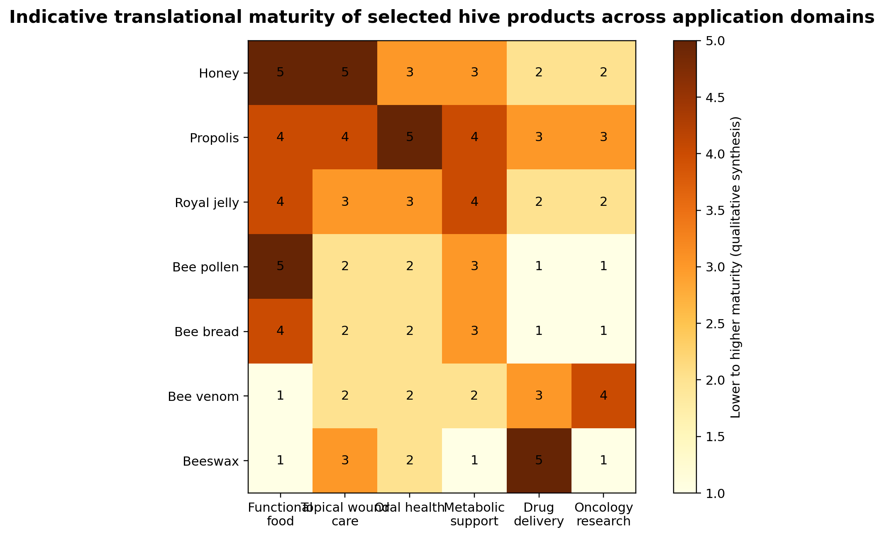
Figure 2. Indicative translational maturity of selected hive products across common application domains. Scores are qualitative and reflect the breadth and maturity of the reviewed evidence rather than formal clinical grading.

13. Pharmaceutical prospects of bee pollen
Although bee pollen is primarily treated as a functional-food ingredient, the literature increasingly attributes pharmaceutical relevance to its antioxidant, anti-inflammatory, antimicrobial, hepatoprotective and potentially anticancer properties. These effects are generally linked to flavonoids, carotenoids, phenolic acids and unsaturated lipids. In vitro and animal studies suggest benefits in oxidative injury, metabolic dysfunction and microbial inhibition, but translation into explicit medicinal products remains limited when compared with honey or propolis. Thus, bee pollen currently occupies an intermediate translational position: richer than a simple supplement, but less clinically mature than a pharmaceutical agent (Komosinska-Vassev et al., 2015; Rodríguez-Pólit et al., 2023; El Ghouizi et al., 2023).
The most plausible pharmaceutical future for bee pollen may lie in standardized extracts or fermented derivatives integrated into oral formulations, anti-inflammatory combinations, nutritional medical foods or supportive care products rather than as a stand-alone drug candidate. This pathway acknowledges both its strengths and its limitations: bee pollen provides broad-spectrum bioactivity and valuable nutrients, but it lacks the strong disease-specific clinical track record currently needed for conventional drug development. Consequently, product-development strategies that bridge nutrition and medicine may be the most realistic translational route (Kacemi et al., 2023; Anjum et al., 2024).

14. Bee bread: fermented pollen as an enhanced functional matrix
Bee bread is produced when stored pollen undergoes natural fermentation in the comb under the influence of bee enzymes and lactic acid bacteria. This transformation alters acidity, preservation, digestibility and metabolite composition, making bee bread a distinct product rather than simply aged pollen. Reviews emphasize that fermentation can improve nutrient release, reduce some structural barriers and enrich the product with organic acids and microbial metabolites. For these reasons, bee bread is increasingly described as a more bioavailable and technologically promising functional product than crude pollen (Bakour et al., 2022; Baky et al., 2023; Aksoy et al., 2024).
Nutraceutically, bee bread is positioned as a fermented superfood with antioxidant, anti-inflammatory, hepatoprotective and microbiota-relevant potential. Its mixed composition of proteins, free amino acids, phenolics, sugars and fermentation-derived compounds makes it an attractive candidate for digestive-health, recovery and metabolic-support formulations. However, because commercial bee bread remains less common than pollen or honey, evidence is still concentrated in compositional and preclinical studies. This means bee bread may currently be one of the most promising yet undertranslated hive products in the nutraceutical landscape (Bakour et al., 2022; Baky et al., 2023).
From a pharmaceutical perspective, bee bread has been evaluated in antimicrobial and antitumor experimental models and may also provide useful fermentation-linked microorganisms or metabolites for food-biotechnology applications. Yet its greatest near-term value may lie in standardized extracts for supportive formulations, especially where both nutrient density and anti-inflammatory effects are desired. As with pollen, bioavailability and standardization are likely to determine whether bee bread remains a niche health food or becomes a serious biomedical ingredient (Bakour et al., 2022; Ilie et al., 2024).

15. Bee venom: pharmacological potency and translational complexity
Bee venom is the most pharmacologically intense hive product and the one that most clearly crosses from natural product into true drug-like territory. It contains melittin, phospholipase A2, apamin, adolapin, mast-cell-degranulating peptide, hyaluronidase and biogenic amines, among other components. This composition gives bee venom remarkable anti-inflammatory, analgesic, immunomodulatory, antimicrobial and cytolytic potential, but it also confers substantial toxicity and allergenic risk. For this reason, bee venom research is as much about delivery control and safety engineering as about intrinsic activity (Bava et al., 2023; Gajski et al., 2024; Sadek et al., 2024).
In preclinical and translational literature, bee venom and melittin are repeatedly explored in arthritis, pain, neurological disease, fibrosis, infection and cancer. Melittin can disrupt membranes and induce apoptosis-related signalling, which partly explains interest in oncology. At the same time, the non-selective membrane activity of melittin is a major barrier to systemic use, since therapeutic effectiveness can be accompanied by hemolysis and tissue damage. This duality makes bee venom an excellent example of a potent natural bioactive whose future depends less on discovering activity and more on refining delivery, dose and target selectivity (Bava et al., 2023; Gajski et al., 2024; Bhardwaj et al., 2025).
Historically, bee venom has also been used in acupuncture-like or sting-based therapeutic approaches for pain and inflammatory disorders. Modern reviews do report anti-inflammatory and analgesic promise, but they also stress that much of the evidence remains preclinical or context-specific and that adverse reactions, including anaphylaxis, make unsupervised or traditional direct-sting therapy inappropriate for broad recommendation. The future of bee venom is therefore likely to favour purified components, recombinant analogues and nanocarriers rather than whole venom administration in conventional settings (Sadek et al., 2024; Stela et al., 2024; Sun et al., 2024).

16. Bee venom in oncology and advanced drug delivery
Among all hive products, bee venom is most actively linked to targeted drug-delivery innovation. Melittin has strong anticancer interest because it can disrupt tumour-cell membranes, modulate apoptosis pathways and sensitize resistant cells, but its lack of selectivity limits direct systemic use. Consequently, researchers have developed liposomes, nanoparticles, peptide conjugates, stimuli-responsive carriers and membrane-coated systems designed to shield melittin in circulation and release it preferentially at tumour sites. This field is important not only for bee venom itself but as a broader proof of concept that aggressive natural peptides can be domesticated through nanomedicine (Gajski et al., 2024; Sadek et al., 2024; Rady et al., 2017).
The same logic extends beyond cancer. Encapsulation can potentially reduce immunogenicity, improve stability and separate beneficial anti-inflammatory effects from acute local toxicity. In this sense, bee venom is less a finished natural medicine than a lead platform for bioinspired pharmacology. Its most realistic future may be as a source of engineered peptides or peptide-loaded systems that preserve function while minimizing the liabilities of crude venom. That translational arc strongly contrasts with honey or pollen, which are more mature in nutraceutical contexts, and shows how hive products occupy very different positions along the food-to-pharma spectrum (Sadek et al., 2024; Bava et al., 2023).

17. Beeswax: from traditional excipient to functional biomaterial
Beeswax is often overshadowed by the more glamorous bioactive hive products, yet it occupies a critical place in pharmaceutical technology and topical product design. Chemically, it is a complex mixture of esters, hydrocarbons, free fatty acids and long-chain alcohols that gives it barrier-forming, structuring and emollient properties. Rather than being valued mainly for systemic pharmacology, beeswax is important as a natural excipient, skin-protective material and carrier in semisolids, cosmetics, dressings, oral films and modified-release dosage forms. In many applications its role is enabling rather than headline therapeutic, but that enabling role is indispensable (Nong et al., 2023; Kurek-Górecka et al., 2020; Strickley, 2004).
Topically, beeswax contributes occlusion, softness, viscosity control and skin-barrier support, which explains its longstanding use in ointments, balms, dermatological products and wound-care adjuncts. Reviews in skincare describe beeswax as a low-cost natural ingredient capable of contributing to moisturization and protective film formation, while also potentially carrying minor antioxidant or antimicrobial advantages when associated with propolis residues or complementary actives. Its clinical value is therefore best understood in formulation context, where it influences residence time, sensory properties and barrier restoration rather than acting as a high-potency standalone drug (Nong et al., 2023; Kurek-Górecka et al., 2020).
In modern pharmaceutical science, beeswax is relevant to sustained-release matrices, taste-masked dosage forms, lipid-based carriers and film-forming systems. Because it is biocompatible, biodegradable and structurally versatile, it has been incorporated into oral films, lipsticks, semisolids and other delivery platforms. This makes beeswax a good example of a hive product whose primary pharmaceutical significance is material science. As biomaterials research expands, beeswax may continue gaining value as a natural structuring agent in multifunctional dressings, transdermal systems and eco-friendly dosage forms (Torabi et al., 2025; Strickley, 2004; Nong et al., 2023).

18. Cross-cutting nutraceutical applications of hive products
Viewed collectively, hive products support several recurrent nutraceutical domains. The first is antioxidant and anti-inflammatory support, relevant to healthy aging, recovery, cardiometabolic wellness and general resilience. Honey, propolis, royal jelly, pollen and bee bread all fit here, though via different molecular routes. The second domain is oral and upper-airway support, where honey and propolis are especially prominent because they offer local contact, soothing action and microbial control. The third is nutrient-dense functional supplementation, where bee pollen, bee bread and royal jelly are most relevant. The fourth is skin and mucosal wellness, which bridges food supplements, cosmeceuticals and supportive medical care (El-Seedi et al., 2022; Kurek-Górecka et al., 2020; Sanlier et al., 2026).
This breadth explains why commercial products often combine multiple hive derivatives, for example honey with propolis lozenges, royal jelly with pollen capsules, or bee bread mixed with honey. Such combinations may improve palatability and create compositional synergy, but they also complicate evidence interpretation because the contribution of each ingredient becomes difficult to isolate. From a responsible nutraceutical-development perspective, product combinations should be guided by chemistry, intended mechanism and safety rather than by a simple 'more is better' assumption attached to bee-derived ingredients (El-Didamony et al., 2024; Bakour et al., 2022).

Table 2. Representative nutraceutical applications of hive products.
Product | Common nutraceutical formats | Primary health-positioning themes | Important caveat
Honey | Functional syrups, tonics, fortified honey blends | Soothing, antioxidant support, energy, general wellness | Still a sugar-rich product; not universally appropriate in all metabolic settings
Propolis | Tinctures, capsules, lozenges, syrups | Immune support, oral comfort, antioxidant and respiratory support | Strong variability by extract and botanical source
Royal jelly | Fresh jelly, lyophilized capsules, ampoules | Healthy aging, vitality, reproductive and immune support | Protein-rich and potentially allergenic
Bee pollen | Granules, powders, capsules, bars | Nutrient density, recovery, antioxidant support | Digestibility and allergenicity depend on processing and host factors
Bee bread | Fermented granules, powders, blends | Gut-friendly, antioxidant and metabolic support | Commercial standardization still limited

19. Cross-cutting pharmaceutical and biomedical applications
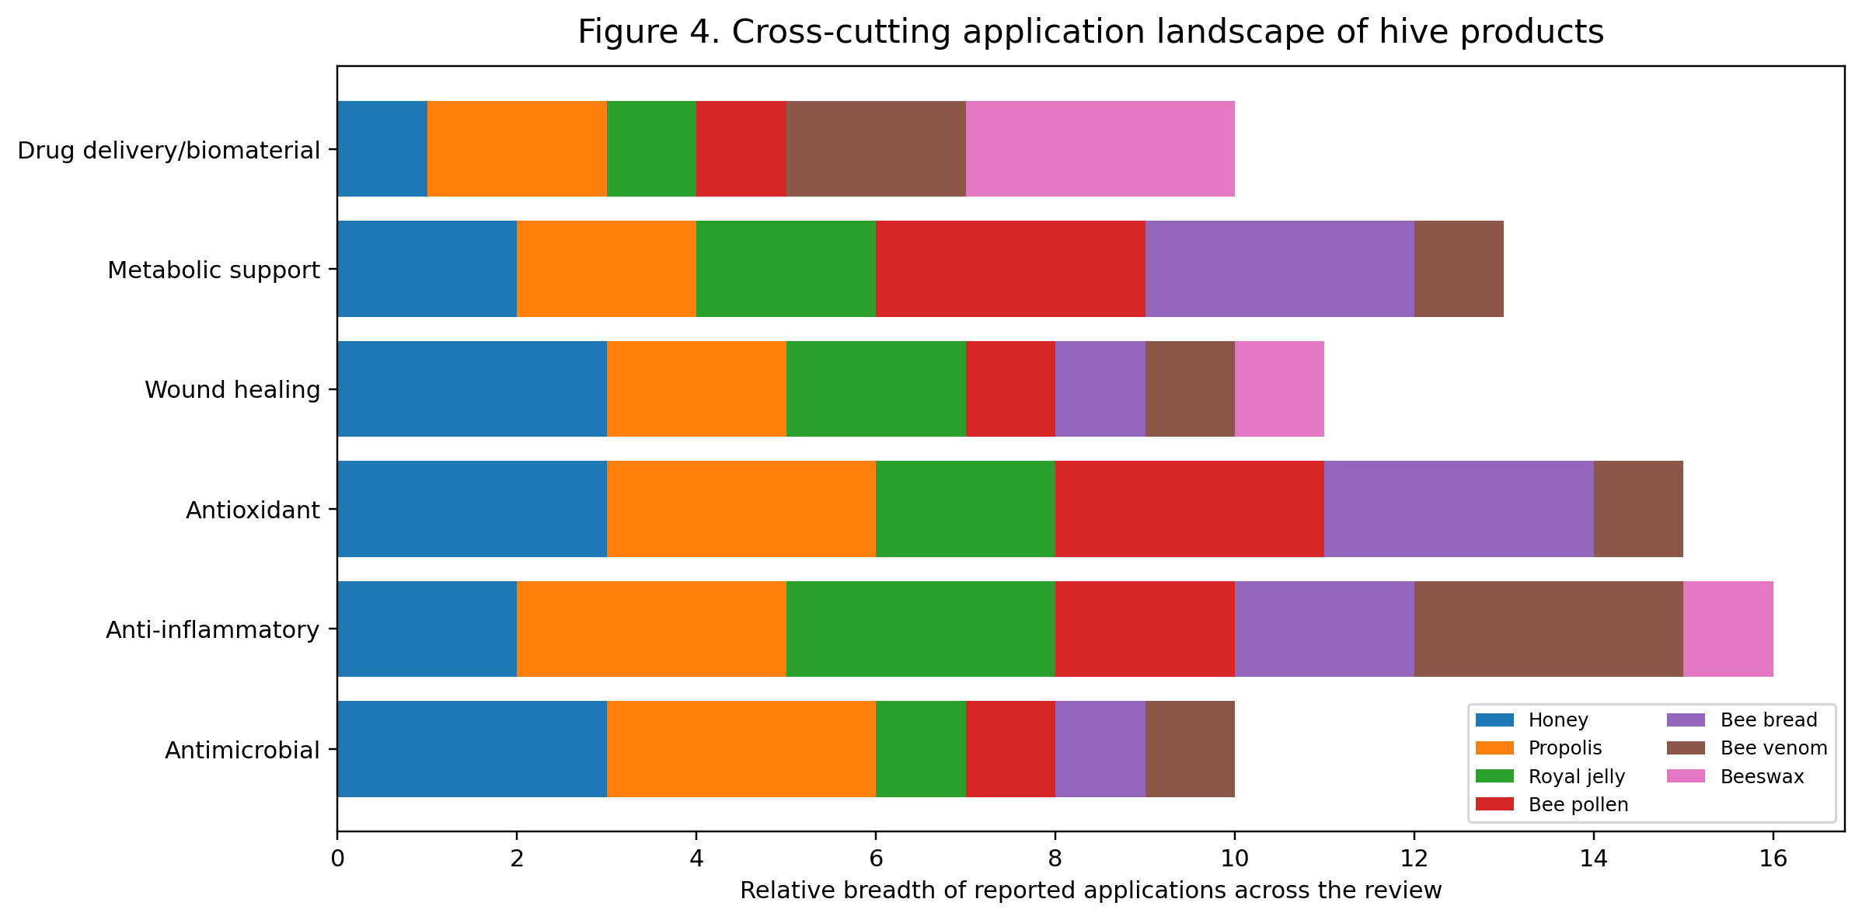
Figure 4. Cross-cutting application landscape of hive products.
Pharmaceutically, hive products cluster into several practical areas. First is wound care, led by honey and supported by propolis, royal jelly, pollen derivatives and beeswax-containing semisolids. Second is oral medicine and dentistry, where propolis, honey and royal jelly are formulated into mouthwashes, gels, varnishes and mucosal-care products. Third is inflammatory and metabolic modulation, where propolis and royal jelly have the most data, though much remains preclinical. Fourth is oncology-adjacent research, particularly for propolis constituents and bee venom peptides. Fifth is biomaterials and drug delivery, where honey hydrogels, propolis nanoformulations, melittin carriers and beeswax matrices illustrate how traditional bee products are being re-engineered into modern therapeutic platforms (Zainuddin et al., 2025; Kustiawan et al., 2024; Sadek et al., 2024).
A key translational insight is that each hive product tends to have a 'best fit' therapeutic niche. Honey excels in surface wound environments; propolis is especially attractive in oral and inflammatory applications; royal jelly is promising in tissue support and immunonutrition; pollen and bee bread are strongest as supportive functional matrices; bee venom is best viewed as a high-potency lead for engineered delivery; and beeswax is indispensable as a material and barrier-former. Recognizing these niche strengths is more productive than treating all hive products as interchangeable 'natural medicines' (El-Seedi et al., 2022; El-Didamony et al., 2024).

20. Formulation science and pharmaceutical engineering
One of the most significant developments in the field is the migration from crude natural products to rationally designed formulations. Honey has been incorporated into hydrogels, films, foams and composite dressings; propolis into sprays, gels, toothpaste, nanoemulsions and polymeric particles; royal jelly into stabilized creams, gels and enriched biomaterials; bee venom into liposomes, nanoparticles and conjugates; and beeswax into oral films, semisolids and sustained-release matrices. This shift matters because formulation often determines whether a hive product remains a folk remedy or becomes a reproducible therapeutic platform (Zainuddin et al., 2025; Kustiawan et al., 2024; Torabi et al., 2025).
Formulation science solves several practical problems. It can improve stability of oxidation-prone or enzyme-rich preparations, mask unpleasant resinous or venom-related sensory properties, control release kinetics, enhance mucosal retention, reduce systemic exposure and improve target selectivity. In the case of melittin, formulation is arguably the only realistic path to broader therapeutic use. In the case of honey and propolis, formulation converts irregular natural materials into elegant pharmaceutical dosage forms suitable for clinic or consumer use. Thus, the future of hive-product medicine is inseparable from delivery science (Sadek et al., 2024; Zainuddin et al., 2025; Kustiawan et al., 2024).
However, formulation cannot compensate for weak raw-material characterization. Even the most advanced carrier system will be difficult to standardize if the starting propolis or royal jelly varies dramatically in composition. This means pharmaceutical engineering must proceed in tandem with robust chemical fingerprinting and quality control. The products most likely to succeed clinically are those in which source selection, extraction profile, marker compounds and delivery design are all controlled as part of a single development strategy (Oršolić and Jazvinšćak Jembrek, 2024; Zullkiflee et al., 2022; El Ghouizi et al., 2023).

Table 3. Selected pharmaceutical and biomedical formulation directions for hive products.
Product | Formulations under use or development | Purpose of formulation engineering
Honey | Medical-grade dressings, hydrogels, films, composites | Retention, moisture balance, controlled exposure, easier dressing changes
Propolis | Mouthwashes, gels, sprays, varnishes, nanoemulsions, nanoparticles | Improve solubility, local retention, standardize dosing, reduce resinous handling issues
Royal jelly | Topical gels, creams, stabilized extracts, biomaterial enrichments | Preserve labile proteins/lipids and improve storage stability
Bee venom / melittin | Liposomes, polymeric nanoparticles, conjugates, responsive carriers | Reduce off-target toxicity and improve selective delivery
Beeswax | Ointment bases, semisolids, oral films, sustained-release matrices | Structure, occlusion, release modification and dosage-form integrity

21. Safety, toxicology and contraindications
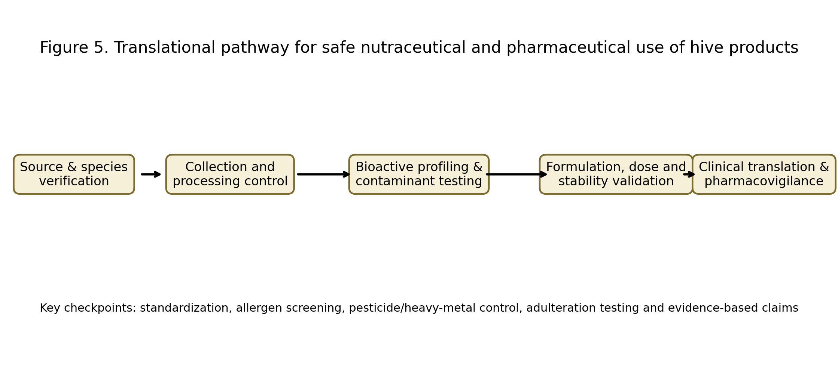
Figure 5. Translational pathway for safe nutraceutical and pharmaceutical use of hive products.
The safety profile of hive products ranges from broadly favourable to highly restrictive depending on the product, route and host factors. Honey is generally safe for older children and adults but is contraindicated in infants because of the risk of botulism from spores. Propolis can cause contact allergy and mucosal irritation in sensitized individuals. Royal jelly may trigger allergic reactions, including in atopic patients. Bee pollen and bee bread can provoke reactions in pollen-sensitive individuals and may accumulate contaminants. Bee venom carries the highest acute risk, including anaphylaxis, severe pain and tissue injury. These differences underscore that 'natural' does not mean uniformly safe (Ali and Kunugi, 2020; Oršolić and Jazvinšćak Jembrek, 2024; Bava et al., 2023).
Contamination is another cross-cutting safety issue. Heavy metals, pesticides, environmental pollutants, microbial contamination and adulteration can affect honey, pollen, propolis and royal jelly depending on geography and production practice. In pharmaceutical contexts, sterilization and microbiological control become especially important, whereas nutraceutical products require validated sourcing and residue testing. This is one reason medical-grade honey differs fundamentally from culinary honey and why clinical translation of other hive products will require similarly disciplined quality systems (Pasupuleti et al., 2017; El-Didamony et al., 2024).
Dose and interaction concerns also deserve attention. Polyphenol-rich extracts can interact with oxidative pathways and possibly with medications; sugar-rich preparations are not universally appropriate in glycemic disorders; and venom peptides demand highly controlled dosing. Patients with severe atopy, asthma, mast-cell disorders or prior bee-product allergy need particular caution. Therefore, healthcare positioning of hive products should emphasize risk stratification and evidence-based indication rather than indiscriminate wellness promotion (Botezan et al., 2023; Sadek et al., 2024; Nong et al., 2023).

22. Standardization, quality control and regulatory translation
The single greatest obstacle to advancing hive products from promising natural agents to dependable medical products is inadequate standardization. Unlike synthetic drugs, hive products are intrinsically variable mixtures. Without clear standards for botanical origin, extraction method, marker compounds, purity, contaminants, moisture and storage stability, studies become difficult to compare and products become difficult to regulate. This challenge is especially pronounced for propolis and pollen, where compositional variability is substantial, but it also affects honey and royal jelly when therapeutic claims are made (Zullkiflee et al., 2022; El Ghouizi et al., 2023; Kumar et al., 2024).
Quality control frameworks should therefore include physicochemical profiling, chromatographic fingerprinting, defined marker compounds, microbial testing, contaminant screening and stability assessment. For royal jelly, 10-HDA is often used as a marker; for propolis, CAPE or flavonoid fingerprints may be informative; for bee venom, quantified peptide composition is necessary; and for honey, parameters such as moisture, peroxide activity, methylglyoxal in specific honeys and absence of adulteration are essential. Regulatory translation will depend on moving from vague natural-product identity to analytically defined preparations fit for a claimed use (Oršolić and Jazvinšćak Jembrek, 2024; Gajski et al., 2024; Tashkandi et al., 2021).
A second challenge is category placement. The same product may be sold as a food, supplement, cosmetic, medical device-associated dressing or medicine depending on jurisdiction and intended use. This regulatory fluidity can encourage overstatement in the marketplace and underinvestment in rigorous trials. Clearer regulatory pathways for standardized hive-product formulations would benefit both consumers and developers by distinguishing evidence-supported products from generalized natural-health marketing (El-Seedi et al., 2022; Sanlier et al., 2026).

23. Research gaps and future directions
Several priorities emerge for future research. First, more randomized controlled trials are needed, especially for oral health, wound care, metabolic support and supportive oncology applications. Second, studies must characterize the exact preparation used rather than referring generically to 'propolis' or 'honey'. Third, comparative formulation studies should identify whether whole products, enriched fractions or encapsulated systems provide the best balance of efficacy and safety. Fourth, adverse-event reporting should be far more rigorous, particularly for allergenic products such as royal jelly, pollen and bee venom (Tang et al., 2024; Kumar et al., 2024; Sadek et al., 2024).
A particularly promising avenue is the convergence of hive products with advanced biomaterials and nanomedicine. Honey hydrogels, propolis nanoparticles, melittin-loaded carriers and beeswax-based films demonstrate that the field is moving beyond raw natural remedies into engineered systems with tunable performance. Another future direction is the integration of omics-based profiling to link source chemistry with biological performance, thereby improving standardization and helping identify responder populations. Such approaches can transform hive-product science from descriptive bioactivity reports into precision natural-product development (Kustiawan et al., 2024; Zainuddin et al., 2025; Gajski et al., 2024).
Finally, sustainability and ethical sourcing cannot be ignored. Rising demand for royal jelly, pollen or venom should not compromise bee welfare or ecological health. Responsible apicultural practice, traceable sourcing and biodiversity protection are not peripheral concerns; they are prerequisites for any long-term bioeconomy built around hive products. A scientifically credible future for apitherapeutics must therefore be both clinically rigorous and environmentally responsible (El-Didamony et al., 2024; Sanlier et al., 2026).

24. Conclusion
Hive products occupy a uniquely broad translational spectrum. Honey has achieved the clearest clinical maturity in wound management and mucosal support; propolis stands out in oral-health, inflammatory and chronic-disease adjunct research; royal jelly is a promising immunonutritional and regenerative supplement; bee pollen and bee bread are powerful functional-food matrices with expanding biomedical relevance; bee venom is a potent but safety-constrained pharmacological source for targeted delivery and oncology-related innovation; and beeswax remains a highly valuable natural excipient and barrier biomaterial. Together, they illustrate how products once confined to traditional apitherapy can now be reinterpreted through chemistry, formulation science and evidence-based medicine (Pasupuleti et al., 2017; El-Seedi et al., 2022; El-Didamony et al., 2024).
At present, the strongest message from the literature is neither uncritical endorsement nor dismissal. Instead, it is stratification. Some applications, such as medical-grade honey in wound care or propolis-based oral-care adjuncts, are already reasonably mature. Others, such as royal-jelly precision formulations or melittin nanomedicine, remain high-promise but translationally early. The future success of hive products in nutraceutical and pharmaceutical practice will depend on disciplined standardization, mechanism-linked indication selection, intelligent delivery design and stronger clinical testing. When these conditions are met, hive products can move from being culturally valued natural substances to scientifically validated components of modern integrative therapeutics (Tang et al., 2024; Oršolić and Jazvinšćak Jembrek, 2024; Sadek et al., 2024).

References
1. Pasupuleti VR, Sammugam L, Ramesh N, Gan SH. Honey, propolis, and royal jelly: A comprehensive review of their biological actions and health benefits. Oxid Med Cell Longev. 2017;2017:1259510.
2. El-Seedi HR, Eid N, El-Wahed AAA, Rateb ME, Afifi HS, Algethami AF, et al. Honey bee products: Preclinical and clinical studies of their anti-inflammatory and immunomodulatory properties. Front Nutr. 2022;8:761267.
3. El-Didamony SE, Gouda HIA, Zidan MMM, Amer RI. Bee products: An overview of sources, biological activities and advanced approaches used in apitherapy application. Biotechnol Rep (Amst). 2024;44:e00862.
4. Ali AM, Kunugi H. Apitherapy for age-related skeletal muscle dysfunction (sarcopenia): A review on the effects of royal jelly, propolis, and bee pollen. Foods. 2020;9(10):1362.
5. Tashkandi H, Benmoussa A, Hssaine K, Aarab L, Mechchate H, Es-Safi I, et al. Honey in wound healing: An updated review. Molecules. 2021;26(21):6557.
6. Tang Y, Jiang T, Liu W, Zhou H, et al. Efficacy and safety of honey dressings in the management of chronic wounds: A systematic review and meta-analysis. Int Wound J. 2024.
7. Chrysostomou D, Ifandi V, et al. Medical-grade honey is a versatile wound care product in the elderly: a narrative review. Geriatrics. 2024.
8. Zainuddin ANZ, et al. A comprehensive review of honey-containing hydrogel for wound healing and skin tissue regeneration. Int J Mol Sci. 2025;26:e11942582.
9. Zullkiflee N, Taha H, Usman A. Propolis: Its role and efficacy in human health and diseases. Molecules. 2022;27(18):6120.
10. Chavda VP, Mistry KJ, et al. Propolis and their active constituents for chronic diseases. Biomed Pharmacother. 2023;157:114385.
11. Abbasi AJ, Mohammadi F, Bayat M, et al. Applications of propolis in dentistry: A review. Ethiop J Health Sci. 2018;28(4):505-512.
12. Saeed MA, Muhammad N, Khan H. Effectiveness of propolis in maintaining oral health: A scoping review. Curr Pharm Des. 2021;27(42):4344-4354.
13. Etebarian A, et al. Propolis as a functional food and promising agent for oral health and microbiota balance: A review study. Food Sci Nutr. 2024.
14. Kurek-Górecka A, Górecki M, Rzepecka-Stojko A, Balwierz R, Stojko J. Bee products in dermatology and skin care. Molecules. 2020;25(3):556.
15. Oršolić N, Jazvinšćak Jembrek M. Royal jelly: Biological action and health benefits. Int J Mol Sci. 2024;25(11):6023.
16. Botezan S, Baci GM, Bagameri L, Pașca C, Dezmirean DS. Current status of the bioactive properties of royal jelly: A comprehensive review with a focus on its anticancer, anti-inflammatory, and antioxidant effects. Molecules. 2023;28(3):1510.
17. Kumar R, Thakur A, Kumar S, Hajam YA. Royal jelly a promising therapeutic intervention and functional food supplement: A systematic review. Heliyon. 2024;10(17):e37138.
18. Komosinska-Vassev K, Olczyk P, Kaźmierczak J, Mencner L, Olczyk K. Bee pollen: Chemical composition and therapeutic application. Evid Based Complement Alternat Med. 2015;2015:297425.
19. Thakur M, Nanda V. Composition and functionality of bee pollen: A review. Trends Food Sci Technol. 2020;98:82-106.
20. El Ghouizi A, et al. Bee pollen as functional food: Insights into its composition and therapeutic properties. Antioxidants (Basel). 2023;12(3):557.
21. Baky MH, Abouelela MB, Wang K, Farag MA. Bee pollen and bread as a super-food: A comparative review of their metabolome composition and quality assessment in the context of best recovery conditions. Molecules. 2023;28(2):715.
22. Bakour M, Laaroussi H, Ousaaid D, El Ghouizi A, Es-Safi I, Mechchate H, Lyoussi B. Bee bread as a promising source of bioactive molecules and functional properties: An up-to-date review. Antibiotics (Basel). 2022;11(2):203.
23. Bava R, Castagna F, Musella V, Lupia C, Palma E, Britti D. Therapeutic use of bee venom and potential applications in veterinary medicine. Vet Sci. 2023;10(2):119.
24. Sadek KM, et al. Harnessing the power of bee venom for therapeutic and regenerative medical applications: An updated review. Front Pharmacol. 2024;15:1412245.
25. Gajski G, Leonova E, Sjakste N, et al. Bee venom: Composition and anticancer properties. Toxins (Basel). 2024;16(3):117.
26. Rady I, Siddiqui IA, Rady M, Mukhtar H. Melittin, a major peptide component of bee venom, and its conjugates in cancer therapy. Cancer Lett. 2017;402:16-31.
27. Nong Y, Maloh J, Natarelli N, Gunt HB, et al. A review of the use of beeswax in skincare. J Cosmet Dermatol. 2023;22(8):2166-2173.
28. Strickley RG. Solubilizing excipients in oral and injectable formulations. Pharm Res. 2004;21(2):201-230.
29. Torabi P, et al. Designing oral films based on beeswax. Pharmaceutics. 2025.
30. Münstedt K, Männle H. Using bee products for the prevention and treatment of oral mucositis induced by cancer treatment. Molecules. 2019;24(17):3023.
31. Choudhary P, et al. Exploring the potential of bee-derived antioxidants for oral healthcare applications. Antioxidants. 2023;12:1430.
32. Rivera-Yañez N, et al. Biomedical properties of propolis on diverse chronic diseases and its potential applications and health benefits. Nutrients. 2020;13(1):78.
33. Zulhendri F, et al. Propolis in metabolic syndrome and its associated chronic diseases: A narrative review. Biomolecules. 2021;11(3):348.
34. Anjum SI, et al. Bee pollen as a food and feed supplement and a therapeutic intervention: Current status and future directions. Front Nutr. 2024;11:1399486.
35. Kacemi R, et al. Translational research on bee pollen as a source of nutrients and bioactive compounds. Nutrients. 2023;15:2619.
36. Sanlier N, Guler M, et al. Health effects of bee products: A comprehensive review. J Food Biochem. 2026;50:e70001.

