Branding, Labeling & FSSAI Regulations

Submitted By
RESHMATHIYA U

Submitted for the fulfillment of
Three-Days National Training Program
Beekeeping Entrepreneurship

Organized By: Meadow Agriculture

Date of submission :14.03.2026


Branding, Labeling and FSSAI Regulations
A comprehensive review article on Indian food-law compliance, brand communication, packaging control and consumer protection
Article type
Narrative review for academic use. This manuscript integrates Indian statutory requirements, FSSAI regulations, Codex guidance and selected peer-reviewed evidence on consumer understanding, claims, packaging and enforcement.

Word length | Detailed long-form review (designed to remain within an approximately 10,000-word cap)
Primary jurisdiction | India
Core regulators | Food Safety and Standards Authority of India (FSSAI), Department of Consumer Affairs, Customs/Import authorities, State food-safety administrations
Reference style | Vancouver style reference list, with paragraph-end author-year attribution plus numerical citations

“A food label is not merely printed text on a package; it is a legal promise, a safety interface and a public-facing expression of the brand.”

Abstract
Branding, labeling and packaging are among the most visible interfaces between the food business and the consumer. In India, that interface is shaped by the Food Safety and Standards Act, 2006, the Food Safety and Standards (Labelling and Display) Regulations, 2020, the Packaging Regulations, the Advertising and Claims Regulations, import-related directions, and overlapping declaration requirements under legal metrology. Together, these instruments determine what a food may be called, how it may be visually presented, what mandatory declarations must appear, how nutrition and allergen information should be communicated, what claims are permitted, and when a package or advertisement becomes misleading. This review synthesizes the conceptual role of branding in food markets, the statutory architecture of Indian food labeling law, the compliance obligations imposed on food business operators, the evidentiary literature on consumer use of labels, and the emerging policy debates around front-of-pack nutrition labeling, recycled food-contact materials, e-commerce and menu disclosure. The review argues that Indian food regulation increasingly treats labels as a hybrid governance tool: one that protects health, structures competition, supports traceability, and disciplines brand communication without extinguishing legitimate product differentiation. For manufacturers, importers, marketers, regulators and researchers, the central lesson is that compliant food branding is no longer a cosmetic exercise; it is a systems activity requiring legal review, nutrition substantiation, packaging validation, consumer-centric communication and post-market vigilance (Government of India, 2006; FSSAI, 2025; WHO, 2022) [1,2,14].
Keywords: FSSAI; food branding; food labeling; packaging regulations; advertising claims; legal metrology; consumer protection; India; food law; public health nutrition.

1. Introduction
The modern food package performs many functions at the same time. It protects the food, carries legally mandated information, differentiates one product from another, narrates quality and lifestyle cues, and increasingly acts as a compact public-health document. A consumer often encounters the brand name, colour system, slogans, nutrient messages, symbols and statutory declarations in a single visual glance, which means that brand communication and regulatory compliance are inseparable in practice. That is especially true in India, where packaged-food markets are expanding across supermarkets, neighbourhood stores, e-commerce platforms and quick-commerce channels, while non-communicable disease prevention has pushed regulators to strengthen label-based consumer information (WHO, 2022; Bera et al., 2023; Pahlani et al., 2025) [14,21,23].
In legal terms, Indian food labeling is not just a best-practice recommendation but a statutory obligation. Section 23 of the Food Safety and Standards Act, 2006 bars the sale of packaged food unless it is marked and labelled in the manner specified by regulations, and also prohibits labels that are false, misleading or deceptive. Section 24 further prohibits misleading advertisements and unfair trade practices relating to food. These provisions make branding review a matter of legal risk management rather than mere aesthetics, because misleading imagery, exaggerated claims, omission of mandatory declarations or inaccurate nutrient statements can all attract regulatory action (Government of India, 2006; FSSAI, 2022) [1,6].
The policy importance of labels is amplified by consumer behaviour research. Indian studies repeatedly show that people do look at labels, but they do not process all parts of the label equally. Expiry date, price and visible brand cues are usually attended to more often than nutrition information, ingredient lists or comparative health claims. This gap between label visibility and label comprehension explains why regulators are increasingly interested not only in what information is present, but also in its placement, clarity and interpretability. Thus, the science of label design and the law of label disclosure now operate in close dialogue (Vemula et al., 2014; Singh et al., 2022; Priya and Alur, 2023) [19,20,22].
This review addresses that intersection in depth. It explains the meaning of branding in the food context, maps the Indian legal framework administered primarily by FSSAI, analyses the operational requirements for compliant labeling and display, reviews the treatment of claims, packaging and special categories such as imported, vegan, organic and food-service products, and concludes with compliance strategies and future directions. The aim is to provide a practical yet academically grounded account suitable for students, researchers, food business operators and policy readers (FSSAI, 2025; Codex Alimentarius Commission, 2024) [2,15].

2. Review approach and scope
This article is a narrative review built from a regulatory core and a contextual literature layer. The regulatory core comprises the Food Safety and Standards Act, 2006, the latest official compendia of the Food Safety and Standards (Labelling and Display) Regulations and the Packaging Regulations, the Advertising and Claims Regulations, official FSSAI directions on imported foods and recycled PET, the Legal Metrology Act and related government explanations, and selected Codex and WHO policy documents. The literature layer includes peer-reviewed Indian and international publications that examine food-label use, front-of-pack labeling, consumer comprehension and the broader public-health rationale for label policy (Government of India, 2006; FSSAI, 2025; WHO, 2022) [1,2,14].
The scope is intentionally broad because the user-facing term ‘branding’ cannot be understood in food law without its related elements: naming, trade presentation, panel layout, symbols, nutrition disclosures, ingredient transparency, claim substantiation, pack material safety, menu display, e-commerce display and complaint redressal. A food label is therefore treated in this review as a composite governance object rather than a narrow list of declarations. Although this is not a systematic review of all food-label studies, it is designed to be doctrinally accurate, practically useful and up to date with currently available official compendia and directions up to March 2026 (FSSAI, 2025; Department of Consumer Affairs, 2024; Pahlani et al., 2025) [2,9,23].
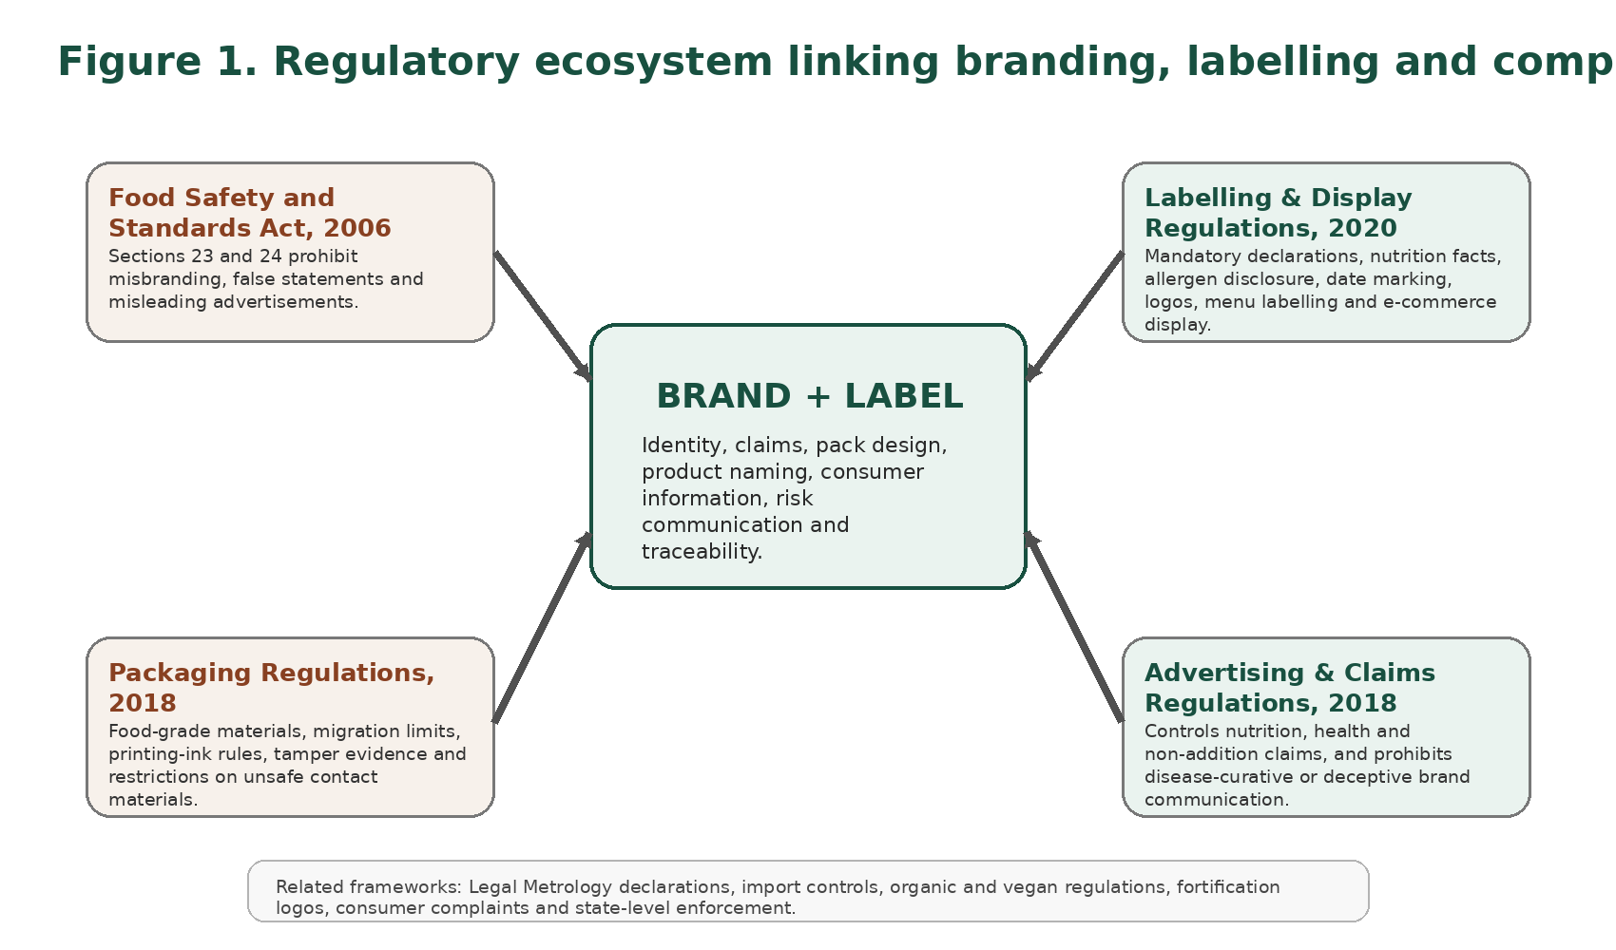
Figure 1. Regulatory ecosystem linking branding, labelling and compliance in India.

3. Branding in the food sector: beyond logos and slogans
Branding in food markets is often misunderstood as a purely promotional exercise comprising a name, logo, colour palette and advertising story. In reality, the food brand is a trust device. It allows a consumer to identify a product over repeated purchases and to associate that product with safety, sensory expectations, nutrition beliefs, origin narratives and social identity. Because food is ingested and may carry allergens, contaminants or long-term diet-related health implications, food branding has a higher ethical and regulatory burden than many other consumer categories. The promise of the brand must therefore remain tethered to demonstrable product truth (WHO, 2022; Codex Alimentarius Commission, 2024) [14,15].
Packaging translates the brand into a physical and visual encounter. The principal display panel, typography, images, claims, category descriptors, seals, symbols and colours together produce what may be called the ‘first reading’ of the product. Consumers frequently make fast decisions based on that first reading before inspecting the back-of-pack information. Consequently, a compliant label must not only contain correct information but must also avoid a front-of-pack presentation that misdirects the consumer regarding the true nature, composition or nutritional quality of the food. The law therefore intervenes not only in wording but also in visual impression (Government of India, 2006; FSSAI, 2022) [1,6].
In food branding, omission can be as misleading as an outright falsehood. A package may technically carry all mandatory data in small print on the reverse panel while the front-of-pack uses oversized imagery, suggestive descriptors or health halo cues that imply a more nutritious or natural product than is justified. Indian law addresses this problem through the combined operation of misbranding rules, claim controls and specific display requirements. The result is a regulatory position that does not prohibit persuasion as such, but prohibits persuasion that distorts identity, composition or risk (Government of India, 2006; FSSAI, 2022) [1,6].
Another reason branding matters is that consumers routinely use brand familiarity as a shortcut for quality and safety. In settings where people do not fully interpret the nutrition panel, the brand may become a substitute for technical understanding. This creates a dual responsibility for food businesses: they must use branding to aid recognition and trust, but they must also ensure that brand trust is not earned through regulatory shortcuts or unverified claims. A successful food brand in the Indian regulatory environment is one whose persuasive architecture remains supportable under documentary scrutiny (Vemula et al., 2014; Priya and Alur, 2023; Pahlani et al., 2025) [19,22,23].
It is also important to distinguish brand law from food law. Trademark registration may protect a name or device mark, but it does not immunize that name or device from food-regulatory review. FSSAI may object to a descriptor, word element or pack presentation if it obscures the true nature of the product, falsely implies therapeutic effect, or conflicts with mandatory declarations. Thus, the legal right to use a mark in commerce remains subject to the obligation to use it honestly in the food context (Government of India, 2006; FSSAI, 2025) [1,2].

4. Institutional and legal architecture governing food labeling in India
The principal statute is the Food Safety and Standards Act, 2006, which created the Food Safety and Standards Authority of India as the apex food regulator. FSSAI is empowered to frame regulations on standards, labelling, packaging, claims, licensing, import controls and related matters. State and Union Territory food-safety administrations, designated officers, food safety officers, food analysts and adjudicatory mechanisms support implementation. This architecture was intended to consolidate a fragmented older regime into a unified risk-based food law framework (Government of India, 2006) [1].
Within that architecture, the Food Safety and Standards (Labelling and Display) Regulations, 2020 are the central operational text for packaged-food disclosures. The regulations specify mandatory declarations, panel rules, nutrient declaration structure, vegan/non-vegetarian symbols, allergen declaration, date marking, country of origin requirements for imported foods, menu labelling obligations for certain food service establishments, and disclosure requirements for non-retail containers and e-commerce contexts. The latest official compendium is therefore a crucial compliance document for industry and enforcement officers alike (FSSAI, 2025) [2].
The Packaging Regulations, though sometimes treated as secondary by marketers, are equally important because the validity of the label depends partly on the safety and suitability of the substrate carrying it. If the pack material is not food grade, permits hazardous migration, uses non-compliant printing practices or relies on prohibited contact materials, then brand compliance on paper cannot rescue product non-compliance in substance. Packaging law and label law are thus operationally linked (FSSAI, 2025; FSSAI, 2025a) [3,5].
The Advertising and Claims Regulations, 2018 complete the picture by governing what the brand may say about nutrition, health, composition and comparative superiority. These regulations define nutrition claims, non-addition claims and health claims, lay down conditions for their use and prohibit certain categories of misleading or fear-based messaging. In effect, they convert claim-making from a marketing instinct into a substantiation exercise (FSSAI, 2022) [6].
A further layer comes from legal metrology. The Legal Metrology Act, 2009 and the related packaged-commodities framework govern declarations such as net quantity, retail sale price and certain pack-related particulars. Indian food businesses therefore operate in a shared compliance space in which FSSAI governs food-specific identity, safety and health information while legal metrology governs measurement and consumer transaction transparency. Failure to harmonize the two leads to common pack-approval errors (Government of India, 2010; Department of Consumer Affairs, 2021; Department of Consumer Affairs, 2024) [7,8,9].
Special-category rules then add further granularity. Organic foods, vegan foods, fortified foods, nutraceuticals, proprietary foods, alcoholic beverages, imported consignments, non-retail containers and digital food sales all have additional or modified disclosure expectations. An effective brand review process must therefore begin by classifying the food correctly before drafting the label, because category misclassification often triggers cascading declaration errors (FSSAI, 2022; FSSAI, 2023; FSSAI, 2025) [10,11,12].
Table 1. Key Indian instruments governing branding, labeling and packaging of foods.
Instrument | Primary focus | What it means for the brand/label | Compliance risk if ignored
FSS Act, 2006 | Misbranding, misleading ads, overall food-law framework | Brand promises must be true and labels must follow regulations | Penalties, adjudication, corrective action, seizure
L&D Regulations, 2020 | Mandatory declarations and display rules | Determines what appears on pack, menu and website | Label defects, import detention, reformulation of packs
Packaging Regulations, 2018 | Food-contact material safety | Brand packaging must use compliant, food-grade substrates | Migration, unsafe pack, recall and enforcement exposure
Advertising & Claims Regulations, 2018 | Nutrition and health claims | Restricts unsupported “healthy”, “low”, “free”, “natural” or disease-related claims | Misleading-advertising liability
Legal Metrology framework | Net quantity, MRP and transaction declarations | Requires correct pack economics and measurement declarations | Consumer-law and metrology action
Import directions/orders | Rectification rules for imported packs | Importer labels and bonded-warehouse corrections have limits | Clearance delays or rejection of consignments

Taken together, these instruments make clear that branding is not an isolated creative function. It is a regulated communication event sitting inside a wider architecture of food safety, trade description, price disclosure and consumer protection. That is why most mature food companies now use cross-functional approval pathways involving regulatory affairs, nutrition, legal, quality assurance, packaging development and marketing before artwork release (Government of India, 2006; FSSAI, 2025; Department of Consumer Affairs, 2024) [1,2,9].

5. Core labeling requirements under the Labelling and Display Regulations
The foundational rule is that every pre-packaged food must carry a set of mandatory declarations in a manner that is legible, truthful and appropriately placed. These typically include the name of the food, the list of ingredients, nutritional information, declaration regarding veg or non-veg status, declaration regarding food additives where relevant, name and complete address of the manufacturer or packer, net quantity, batch/lot/code number, date marking, country of origin for imported food, instructions for use where necessary, and the FSSAI logo with licence number. When different legal instruments govern overlapping declarations, both sets must be satisfied without contradiction (FSSAI, 2025; Department of Consumer Affairs, 2024) [2,9].
The ‘name of the food’ requirement is particularly important from a branding perspective. The name cannot be submerged under a fantasy brand or expressive marketing phrase if that has the effect of obscuring the true nature of the product. For standardized foods, the standardized name or a sufficiently descriptive name is expected. For proprietary foods, the label must still communicate nature and composition adequately. This prevents the brand identity from replacing factual product identity in the consumer’s mind (FSSAI, 2025; Government of India, 2006) [2,1].
The list of ingredients must ordinarily be in descending order of composition by weight or volume at the time of manufacture. This requirement performs several functions: it allows consumers to identify major constituents, detect the presence of disliked or restricted ingredients, compare products within a category and understand whether the front-of-pack imagery reflects the actual composition. In the era of clean-label marketing, ingredient transparency is one of the strongest tests of brand honesty (FSSAI, 2025; Codex Alimentarius Commission, 2024) [2,15].
Allergen declaration has become a critical safety requirement rather than a peripheral courtesy. The regulations require declaration of specified allergenic ingredients, which is particularly significant for consumers with food allergies, intolerances or religious dietary concerns. From a regulatory standpoint, allergen omission is not just bad communication; it may create a direct health hazard. From a brand standpoint, clear allergen communication strengthens consumer trust and reduces post-market complaints and recall exposure (FSSAI, 2025; Codex Alimentarius Commission, 2024) [2,15].
Nutrition information must ordinarily be provided per 100 g or 100 ml or per serving, as prescribed, and may include energy, protein, carbohydrates, total sugars, added sugars, total fat, saturated fat, trans fat and sodium, among other particulars depending on the category. The standardized presentation of nutrition information serves comparability. It prevents brands from choosing flattering serving sizes or non-comparable formats that make unhealthy products appear nutritionally modest. Thus, formatting is itself a regulatory tool for fairness (FSSAI, 2025; WHO, 2022) [2,14].
The declaration regarding vegetarian or non-vegetarian status is an iconic Indian label feature. The regulations prescribe a green filled circle in a square for vegetarian foods and a brown filled triangle in a square for non-vegetarian foods, with size linked to the area of the principal display panel. These symbols must appear in close proximity to the name or brand name on the front of the pack and must be used also in pamphlets, leaflets and advertisements where applicable. Their significance is cultural, religious, ethical and commercial all at once, making them a powerful example of how national food law incorporates local consumer values into pack design (FSSAI, 2025) [2].
Date marking is another area where formal detail matters greatly. Best before, use by or expiry declarations must be presented in the manner specified for shelf-life duration, and certain categories have exemptions or special treatment. The date statement is not a minor print item but a risk-management marker affecting stock rotation, e-commerce display, consumer acceptance and recall management. Because consumers frequently read manufacturing and expiry details more than technical nutrient data, date clarity also has outsized influence on brand trust (FSSAI, 2025; Vemula et al., 2014) [2,19].
Imported foods face heightened scrutiny because their labels often require adaptation to Indian requirements. Country of origin must be declared, and rectification of certain deficiencies may be allowed only in a customs bonded warehouse and not for core particulars such as batch codes, date marking or origin itself. This means importers cannot assume that a globally harmonized pack will automatically clear India; country-specific regulatory artwork is often needed. In cross-border trade, labeling becomes a customs-readiness issue as much as a branding exercise (FSSAI, 2023; FSSAI, 2025) [10,2].
The regulations also extend beyond conventional retail packs. Non-retail containers must carry prescribed particulars and prominently state ‘NOT FOR RETAIL SALE’. This ensures traceability through supply chains such as bulk ingredients, B2B dispatches, catering channels and institutional procurement. The principle behind this rule is significant: the absence of direct retail sale does not remove the need for identity and accountability within the distribution chain (FSSAI, 2025; Codex Alimentarius Commission, 2021) [2,15].
A related but increasingly important extension concerns digital display. Where food is sold or promoted through e-commerce, applicable label information must be made available on the website or platform. This recognizes that consumers now encounter the first reading of the product on a screen rather than on a shelf. In digital commerce, therefore, the label has two lives: a physical life on the package and an informational life online. Compliance must cover both (FSSAI, 2025; Codex Alimentarius Commission, 2024) [2,17].
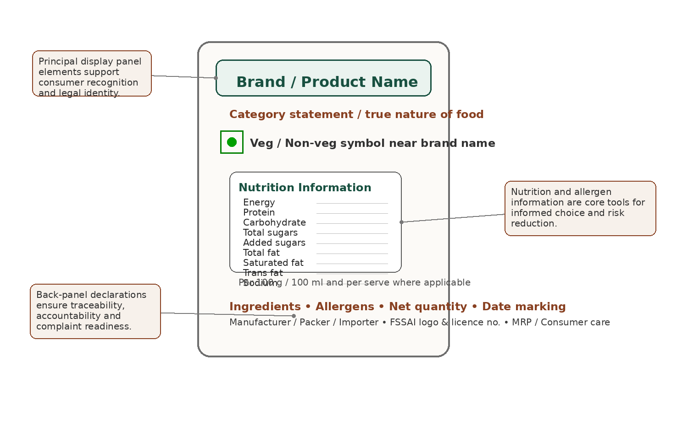
Figure 2. Anatomy of a compliant packaged-food label under Indian rules.
Table 2. Illustrative checklist of mandatory or frequently required declarations on packaged foods in India.
Declaration element | Practical purpose | Branding/compliance note
Name of food | Communicates true identity | Must not be hidden behind fantasy branding
Ingredients list | Composition transparency | Front-of-pack imagery should not contradict ingredient reality
Nutrition information | Comparability and diet assessment | Claim-making should match the nutrition panel
Veg / non-veg symbol | Cultural and dietary recognition | Place near the brand name on front-of-pack
Allergen statement | Risk reduction for sensitive consumers | Critical for safety and liability management
Net quantity / MRP | Transaction transparency | Often governed in tandem with legal metrology
Batch / lot / code | Traceability and recalls | Essential for complaints and enforcement investigations
Best before / expiry / use by | Shelf-life communication | High consumer attention; must be easy to locate
Manufacturer / packer / importer details | Accountability | Supports complaint handling and enforcement service
FSSAI logo and licence no. | Regulatory identification | Mandatory but not to be used as a promotional claim

6. Nutrition labeling, front-of-pack communication and menu disclosure
Nutrition labeling in Indian law is no longer a specialist back-panel issue. It is a major policy instrument in the prevention of obesity, diabetes, hypertension and other diet-related non-communicable diseases. WHO policy guidance places nutrient declarations, supplementary nutrition information, ingredient lists and claim regulation within the same public-health toolkit, because consumers need both accurate data and usable interpretive aids. India’s current system requires standardized nutrition declaration and has actively debated stronger front-of-pack nutrition labeling for foods high in sugar, salt and saturated fat (WHO, 2022; Saleem et al., 2022; Singh et al., 2022) [14,24,20].
The debate around front-of-pack labeling demonstrates a key tension in branding regulation: whether interpretive simplicity should override brand-preferred complexity. From a marketer’s perspective, minimalist warning labels may appear harsh or commercially disadvantageous; from a public-health perspective, they may reduce cognitive burden and allow fast recognition of risk. Indian experimental evidence suggests that warning labels outperform more interpretive formats such as Health Star Rating in helping consumers identify unhealthy packaged foods, even if effects on purchase intention are less immediate. This is why front-of-pack policy remains central to reform discussions (Singh et al., 2022; WHO, 2022) [20,14].
At the same time, nutrition panels only work well when consumers understand them. Studies in India show that people often prioritise price, manufacturing/expiry details and brand cues over nutrient numeracy. Technical label literacy varies by education, age, socioeconomic status and exposure to health information. Therefore, even a legally correct panel may fail to deliver behavioural benefit if it is not accompanied by broader food literacy and interpretive design strategies. Regulation alone cannot solve comprehension gaps, but it can reduce avoidable confusion (Vemula et al., 2014; Priya and Alur, 2023; Pahlani et al., 2025) [19,22,23].
India has also extended disclosure logic to food service. Certain food service establishments, especially those with central licensing or a minimum network size, must display calories and allergen information and indicate vegetarian or non-vegetarian status on menus or menu boards. This is a major conceptual shift because it recognizes that consumers increasingly purchase branded foods outside packaged retail, and therefore deserve meaningful nutrition and risk information at the point of ordering as well. Brand communication in restaurants is thus becoming more label-like (FSSAI, 2025) [2].
The rise of menu labelling also complicates digital ordering and aggregator platforms. If a consumer chooses a branded meal through an app, then the informational duties previously associated with physical menus and packaged labels need functional digital equivalents. Indian rules and Codex guidance on e-commerce both point toward the same principle: the consumer should receive material food information before purchase, not after delivery. This principle will likely become even more important as dark kitchens and platform-native brands expand (FSSAI, 2025; Codex Alimentarius Commission, 2024) [2,17].
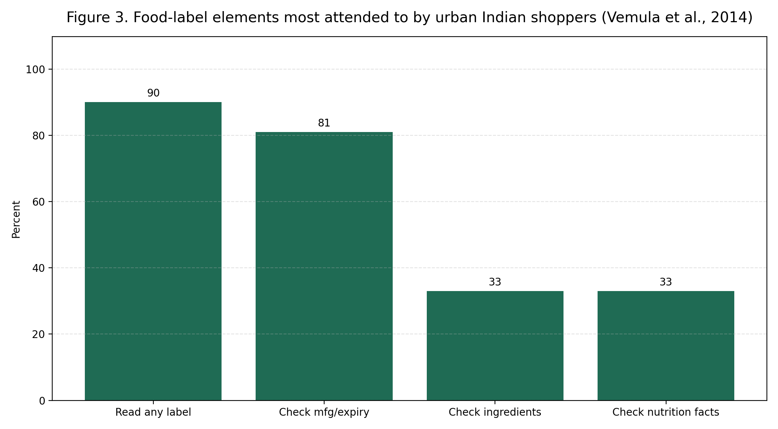
Figure 3. Food-label elements most attended to by urban Indian shoppers, based on reported findings from Vemula et al. (2014).
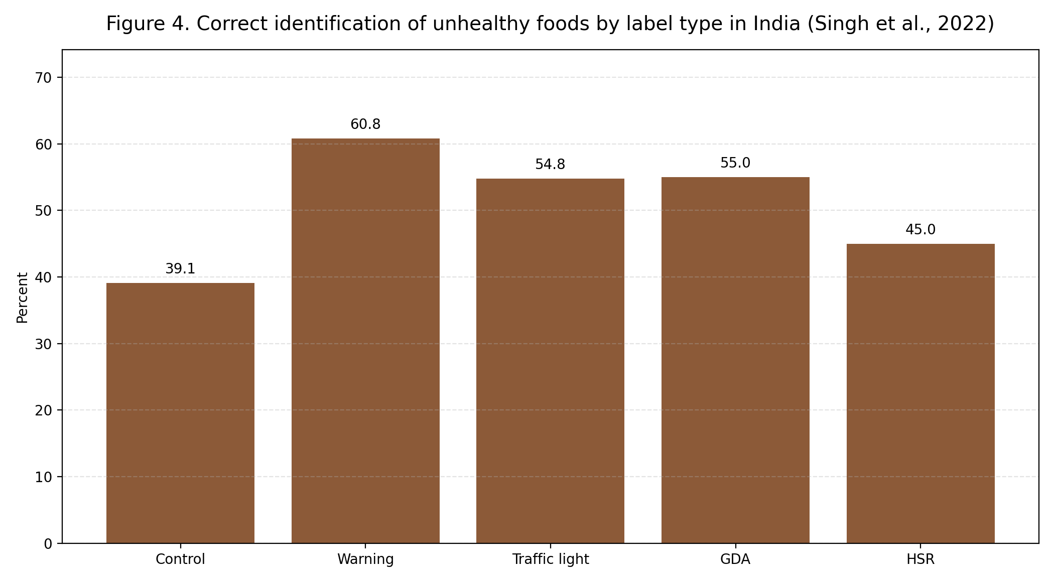
Figure 4. Correct identification of unhealthy packaged foods by label type in India, based on Singh et al. (2022).

7. Claims, endorsements and the discipline of truthful brand communication
Claims are the most direct point at which branding meets regulation. A food business may wish to say that a product is low in fat, high in protein, rich in fibre, natural, traditional, fortified, immunity-supporting or suitable for a specific health-conscious lifestyle. Yet every such statement changes how consumers interpret the product and may generate a ‘health halo’ that affects purchasing. For this reason, the Advertising and Claims Regulations define specific claim categories and control the conditions under which they may be used (FSSAI, 2022; WHO, 2022) [6,14].
Nutrition claims include both nutrient-content claims and comparative claims. They are permitted only when the quantitative conditions set out by regulation are met. This prevents brands from making vague superiority statements that are not measurable or from exploiting tiny formulation differences as large promotional talking points. The law therefore transforms ‘low’, ‘free’, ‘source of’ and related expressions from rhetorical flourishes into regulated descriptors tied to thresholds (FSSAI, 2022; Codex Alimentarius Commission, 2024) [6,16].
Health claims are treated more cautiously because they connect the food to physiological benefit. Under the Indian framework, a health claim must ordinarily combine a statement about the physiological role of a nutrient or ingredient with a statement that the product contains that nutrient or ingredient at an appropriate level. Product-specific health benefit claims require stronger substantiation, and disease-risk-reduction claims are restricted to defined circumstances. This is a deliberately high evidentiary threshold because health language is especially potent in consumer persuasion (FSSAI, 2022) [6].
Non-addition claims—such as ‘no added sugar’ or claims relating to sodium or additive exclusion—may also be used only when specific conditions are met, including disclosure where naturally occurring amounts remain present. This is an important safeguard against literal but misleading phrasing. A fruit product that contains naturally occurring sugars, for example, cannot safely use ‘no added sugar’ in a way that suggests the product is sugar-free or metabolically trivial. The law thus aims to align technical truth with likely consumer interpretation (FSSAI, 2022; WHO, 2022) [6,14].
The treatment of words like ‘natural’, ‘pure’, ‘fresh’, ‘real’, ‘authentic’ and ‘traditional’ is especially relevant to branding because these are classic premiumisation cues. Indian regulations do not treat them as harmless puffery. Their use is regulated through conditions and contextual limitations, reflecting the view that such descriptors meaningfully shape consumer expectations about processing, composition and quality. In the Indian packaged-food market, therefore, heritage and purity branding must be documented, not merely imagined (FSSAI, 2022) [6].
The regulations also prohibit several classes of claims outright. Food must not be presented as preventing, treating or curing disease unless specifically permitted in law. Labels and advertisements must not suggest recommendation by a medical practitioner or health professional unless explicitly allowed, and they must not undermine healthy lifestyle practices or exploit consumer fear. The message is clear: food brands may inform and persuade, but they may not impersonate medicine or manipulate vulnerability (Government of India, 2006; FSSAI, 2022; WHO, 2023) [1,6,18].
Importantly, FSSAI has clarified that the FSSAI logo and licence number themselves are not to be used as promotional claims. They are mandatory identifiers, not badges of superior efficacy. This distinction matters because regulatory approval or licensing is a condition of lawful operation, not a brand differentiator warranting consumer over-interpretation. Turning mandatory compliance symbols into marketing trophies would distort the regulatory baseline (FSSAI, 2022) [6].
Table 3. Practical classification of common food-brand claims under Indian law.
Claim type | Typical examples | Regulatory treatment | Key caution
Nutrition-content claims | “Low fat”, “source of protein” | Permitted only when thresholds are met | Need nutrient calculations and formulation records
Comparative claims | “Reduced sodium”, “more fibre” | Require valid comparison basis | Comparator product and magnitude must be defensible
Health claims | “Calcium helps maintain bones” | Allowed subject to conditions and substantiation | Cannot drift into disease-treatment language
Non-addition claims | “No added sugar” | Allowed with conditions and disclaimers where needed | Must not imply absolute absence where naturally occurring amounts remain
Lifestyle descriptors | “Natural”, “fresh”, “pure”, “authentic” | Regulated contextually | High risk of overstatement in processed foods
Prohibited/unsafe claims | “Cures diabetes”, “doctor recommended” | Generally prohibited unless expressly authorized | High enforcement exposure and misleading-ad risk

For industry, the practical implication is that every claim should be traceable to a dossier. That dossier should ordinarily contain the exact claim wording, nutrition or compositional basis, laboratory or formulation evidence where necessary, label context, comparator rationale for comparative claims, and legal review notes. When claim approval is handled in this disciplined way, branding becomes stronger rather than weaker because the business can defend what it says at launch and after launch (FSSAI, 2022; FSSAI, 2025) [6,24].

8. Packaging regulations and the safety of the communication medium
A food label cannot be separated from the package that carries it. The Packaging Regulations require that materials which directly contact food or are likely to contact food under normal conditions must be food grade and suitable for the product, storage conditions and intended use. Packaging must not endanger human health, bring about unacceptable change in composition or alter organoleptic characteristics. This is a foundational principle: the communication medium must not contaminate what it markets (FSSAI, 2025a) [3].
The regulations also address operational details that are easy to underestimate in brand development, such as reuse of containers, the use of printing inks, prohibitions on newspaper for wrapping food, and the structure of multilayer packaging. If the printed surface of a package comes into direct contact with food or if non-food-grade materials are used in inner layers, the package may become non-compliant regardless of how attractive or informative the label appears. Artwork approval must therefore be coordinated with packaging engineering (FSSAI, 2025a) [3].
Migration limits are one of the most technical but important parts of packaging law. The regulations and related schedules prescribe overall migration and specific migration controls for materials and substances so that constituents do not transfer into food at unsafe levels. These limits are particularly significant for plastics, coatings, adhesives and additives used in food-contact systems. In compliance practice, claims such as ‘premium packaging’, ‘fresh-lock technology’ or ‘sustainable pack’ should never outpace documentary evidence of food-contact suitability (FSSAI, 2025a) [3].
Recent Indian developments concerning recycled PET illustrate the evolution of packaging regulation from simple material permission toward controlled circularity. The Packaging First Amendment Regulations, 2025 and the subsequent guidelines on recycled PET as food contact material permit movement toward recycled content, but only subject to standards, decontamination performance, traceability, migration testing and prescribed marking. In other words, sustainability branding is being welcomed, but through a controlled evidence-based gate rather than through unverified green claims (FSSAI, 2025b; FSSAI, 2025c) [4,5].
For brand owners, this is strategically important. Sustainability cues increasingly influence consumer preference, yet environmental branding can become misleading if the packaging substrate is not actually compliant with recycled-content rules, food-contact standards or traceability requirements. The future of food branding will therefore require joint substantiation of health safety and sustainability safety. The law is moving toward making both visible (FSSAI, 2025b; Pahlani et al., 2025) [4,23].

9. Imported foods, e-commerce, food service and other special scenarios
Imported foods face a distinctive challenge because the label is often designed for multiple jurisdictions at once. Indian law, however, requires localization of critical particulars such as country of origin, importer details and FSSAI-related declarations. FSSAI has allowed rectification of certain labelling deficiencies in customs bonded warehouses, but not of all deficiencies, and not of the most identity-sensitive particulars. This means that import compliance is partly a pre-clearance design problem and only partly a post-arrival correction problem (FSSAI, 2023; FSSAI, 2025) [10,2].
E-commerce creates a different problem: consumers may decide based on thumbnail images, abbreviated descriptions or platform-generated information cards rather than by handling the physical package. The legal answer increasingly favours pre-purchase disclosure. Material food information should appear on the website or platform, not remain hidden until delivery. This requires food businesses to harmonize packaging artwork databases, retailer portals and marketplace listings so that the legal pack identity is accurately mirrored in the digital product page (FSSAI, 2025; Codex Alimentarius Commission, 2024) [2,17].
Food service and restaurant branding now occupy an intermediate zone between packaging law and menu communication law. When menu boards or digital menus display calories, allergens and vegetarian/non-vegetarian status, the hospitality brand effectively becomes a label-bearing food business. For national chains and platform-led food service brands, menu disclosure is not a peripheral compliance step but a core part of standardized brand operations. The same applies to franchised brands that must ensure uniform disclosure across outlets (FSSAI, 2025) [2].
Organic foods add another layer because the label communicates not only composition but also process assurance. FSSAI’s Organic Foods Regulations recognise two certification systems—PGS and NPOP—and permit marketing of organic food subject to compliance with that framework. Here, the brand proposition often rests heavily on trust, provenance and perceived purity, making misuse of organic language especially sensitive. The organic claim must therefore be backed by valid certification pathways and correct logo use rather than by loose lifestyle imagery (FSSAI, 2022b; FSSAI, 2020) [11,13].
Vegan foods similarly require category-specific care. Under the Vegan Foods Regulations, the food must satisfy the regulatory meaning of vegan, and product approval is linked to logo endorsement guidance issued by FSSAI. Because vegan branding speaks simultaneously to ethics, diet and ingredient sourcing, false or careless use of vegan markers can amount to both consumer deception and category erosion. Businesses entering this space need rigorous ingredient and process mapping, including packaging and cross-contamination considerations (FSSAI, 2022c; FSSAI, 2022d) [12,13].
Fortified foods show how category-specific labels can also serve public-health policy. Products covered by fortification rules must carry the appropriate fortification logo and related declarations. In this setting, the label becomes a vehicle for nutrition intervention while the brand benefits from association with regulated enhancement. Yet the same principle applies: the public-health promise of the logo depends on real conformity to technical standards and not just on attractive front-of-pack execution (FSSAI, 2025; WHO, 2022) [2,14].
Taken together, these special scenarios demonstrate that the Indian label is no longer a static sticker attached to a retail pack. It is a distributed information system spanning imports, warehouses, menus, websites, apps, bulk supply chains and special certification ecosystems. The brands that succeed in this environment are those that treat labeling as data governance as much as visual design (FSSAI, 2025; Codex Alimentarius Commission, 2024) [2,17].

10. Enforcement, penalties and complaint pathways
The regulatory significance of labels becomes clear when one examines enforcement provisions. Misbranded food may attract penalties and directions for corrective action, while misleading advertisements attract separate penalties under the Act. General contraventions can also be penalized where a specific penalty is not otherwise provided. These enforcement tools matter because labels and claims are not merely advisory texts; they are legally cognizable representations made in commerce (Government of India, 2006) [1].
Enforcement in practice can occur through inspection, sampling, import scrutiny, adjudication, consumer complaints, inter-agency referrals and market surveillance. A defective label may lead to relabelling directions, detention of consignments, product withdrawal, prosecution in serious cases or repeated regulatory scrutiny of future artwork. The cost of non-compliance therefore extends far beyond a single pack correction and may include logistics loss, reputational damage and retailer disruption (Government of India, 2006; FSSAI, 2025) [1,2].
Recent FSSAI initiatives also show a move toward participatory enforcement. Consumers have been given digital pathways to report misleading claims on food products through official systems, making post-market monitoring more decentralized and immediate. This increases the practical importance of claims governance because problematic brand communication can now surface not only through inspectors and competitors but through ordinary consumers reading packs on the shelf or at home (FSSAI, 2025d) [24].
For businesses, the best response is not merely defensive. A strong internal complaint-handling and escalation process can convert label-related feedback into a compliance asset. If complaints are classified by type—claim confusion, allergen omission, price mismatch, date illegibility, ingredient surprise, certification doubt—the business can identify recurring artwork weaknesses and improve both risk control and customer trust. Compliance intelligence and brand stewardship should therefore feed each other (FSSAI, 2025d; Pahlani et al., 2025) [24,23].

11. Consumer behaviour, label literacy and public-health significance
Consumer studies in India show a recurring paradox: many people report reading labels, yet the part of the label they read most is often not the nutrition panel. Manufacturing date, expiry date, price and brand identity commonly attract more attention than nutrient content or technical ingredient information. This suggests that the legal presence of information is not equivalent to effective communication. The policy challenge is therefore to move from ‘disclosure sufficiency’ to ‘disclosure usability’ (Vemula et al., 2014; Priya and Alur, 2023; Pahlani et al., 2025) [19,22,23].
Label literacy is influenced by education, numeracy, time pressure, shopping context, trust in the brand, prior health conditions, family dietary practices and the visual complexity of the package. A dense pack covered in marketing slogans may technically comply while still overwhelming the consumer’s decision-making process. Simplified front-of-pack warnings, clearer allergen emphasis and better menu disclosures are policy responses to this behavioural reality. They do not replace detailed information; they stage it more effectively (WHO, 2022; Singh et al., 2022) [14,20].
From a public-health viewpoint, food labels can support healthier diets only when they achieve three outcomes: visibility, comprehension and actionability. Visibility means the information can be found; comprehension means it can be understood; actionability means it can guide a comparison or decision. India’s current experience suggests that visibility is improving, comprehension is uneven and actionability remains partial. Hence, labeling reform needs to be accompanied by food literacy, school education, digital decision tools and retail-environment support (WHO, 2022; Priya and Alur, 2023; Pahlani et al., 2025) [14,22,23].
Children and adolescents merit special attention because brand imagery, cartooning, flavour cues and promotional architecture may exert stronger influence on them than numeric nutrition declarations. WHO has increasingly emphasized the harmful impact of food marketing on children, particularly for foods high in sugar, salt and unhealthy fats. In this context, packaging itself can function as advertising, which means that child-directed visual branding deserves regulatory scrutiny even when technically separate from broadcast or digital advertising (WHO, 2023; WHO, 2022) [18,14].
A sophisticated regulatory approach therefore treats the food label as part of the broader food environment. The same label that helps an informed adult compare sodium content may also generate a health halo in another consumer through a ‘natural’ claim, a green colour scheme or athletic imagery. This is why truthful labeling is necessary but not sufficient; interpretation matters. Brand ethics, evidence-based design and consumer education must operate alongside statutory minimums (WHO, 2022; FSSAI, 2022; Priya and Alur, 2023) [14,6,22].

12. Building a compliant label: a practical workflow for food businesses
The first step in label development is correct product classification. The business must determine whether the food is standardized, proprietary, fortified, organic, vegan, nutraceutical, imported, alcoholic, non-retail, or subject to any category-specific regime. Many labeling errors begin upstream because teams draft artwork before settling the regulatory identity of the product. Classification should therefore precede claim development and graphic execution (FSSAI, 2025; FSSAI, 2022c) [2,12].
The second step is building a factual data pack. This includes the approved product name, formulation sheet, ingredient order, allergen mapping, additive status, nutritional calculations or laboratory data, pack size, shelf-life basis, date-marking format, manufacturer/packer/importer particulars, licensing details and price-declaration inputs. Without this data pack, artwork review becomes speculative and heavily dependent on assumptions, which is unsafe for both legal and design reasons (FSSAI, 2025; Department of Consumer Affairs, 2024) [2,9].
The third step is claims governance. Every descriptor beyond neutral identity wording should be screened: low/reduced/free/source claims, ‘natural’ or ‘fresh’ language, protein or fibre highlights, immunity or wellness suggestions, endorsement-like wording, sustainability claims and comparative superiority statements. The review must assess whether the claim is permissible, whether substantiation is available, whether disclaimer wording is needed, and whether the visual context exaggerates the claim. This is the stage at which many future enforcement problems can be prevented cheaply (FSSAI, 2022; WHO, 2022) [6,14].
The fourth step is pack and panel verification. Teams should check panel hierarchy, font legibility, principal display panel crowding, proximity of mandatory symbols to the brand name, contrast, date-print area, barcode placement, and whether information shown online matches the physical label. Where packaging materials or inks change, packaging-compliance revalidation may be needed. In other words, label approval is not only a text review but also a layout and substrate review (FSSAI, 2025; FSSAI, 2025a) [2,3].
The fifth step is post-launch vigilance. Complaints, regulatory observations, retailer queries, export-import feedback and evolving notifications should all be fed into a controlled change-management process. Because Indian food law continues to evolve through amendments, FAQs, directions and category-specific notifications, label compliance cannot be treated as a one-time event. It is an ongoing governance cycle embedded in the product life cycle (FSSAI, 2025; FSSAI, 2025d) [2,24].
Table 4. Recommended label-approval workflow for food business operators.
Stage | Lead function | Core questions | Output
1. Product classification | Regulatory affairs / R&D | Which regulatory category applies? | Category decision memo
2. Data pack creation | R&D / quality / nutrition | What is the exact composition, shelf life and declaration base? | Approved technical dossier
3. Claim screening | Regulatory / legal / marketing | Which claims are allowed, limited or prohibited? | Claim matrix with justification
4. Artwork review | Packaging + regulatory + design | Are all mandatory elements correctly placed and legible? | Approved master artwork
5. Pack-material compliance | Packaging / QA | Are material, ink and migration aspects compliant? | Material conformity records
6. Market release and monitoring | Commercial + compliance | Does online/offline display match approved artwork? | Release note and change-control log

13. Emerging issues and future directions
One of the most important ongoing debates in India is the eventual shape of front-of-pack nutrition labeling for foods high in fat, sugar and salt. Draft amendments and regulatory discussion over recent years indicate strong policy interest, but the final operational form remains a matter of continuing development. For industry, uncertainty is itself a planning issue: pack architecture should be designed with flexibility so that future front-of-pack requirements can be incorporated without brand collapse or excessive artwork redesign (FSSAI, 2022e; FSSAI, 2024) [25,26].
Another emerging area is the regulation of sustainability claims on packs. As circular packaging, recycled materials, carbon claims and environmentally themed branding expand, regulators may increasingly scrutinize whether ‘green’ cues are substantiated or merely reputational theatre. The recycled PET framework already signals this shift by linking sustainability-adjacent messaging to traceability, decontamination, migration control and specified marking requirements. The next frontier may involve more explicit controls on environmental representations in food packaging (FSSAI, 2025b; FSSAI, 2025c) [4,5].
Digital commerce and platform selling will likely continue to blur the boundary between label, advertisement and product listing. Search results, platform badges, short descriptions and ‘healthy choice’ filters may shape consumer perception before any statutory label is opened. Regulators may therefore need increasingly integrated rules for digital food information, platform accountability and the prominence of mandatory disclosures. Codex has already moved in this direction, and Indian practice is likely to evolve further (Codex Alimentarius Commission, 2024; FSSAI, 2025) [17,2].
There is also growing scope for data-driven compliance. Structured label databases, artwork-version control, QR-linked supplementary information, AI-assisted claim screening and automated mismatch detection between formulation and pack could all improve accuracy. However, digital supplementation should not become an excuse for shrinking essential on-pack information below usable visibility. The principle should remain that core consumer-protection information must be accessible at the point of choice, whether through print, menu display or compliant digital augmentation (WHO, 2022; Codex Alimentarius Commission, 2024) [14,17].
Finally, future regulation will likely continue balancing two objectives that are sometimes framed as opposites but are in fact complementary: consumer protection and fair competition. Clear rules reduce the advantage of irresponsible marketers who rely on ambiguous health halos, pseudo-natural claims or design-led concealment. In that sense, strong labeling law protects not only consumers but also honest brands. The more disciplined the market becomes, the more valuable credible branding becomes (Government of India, 2006; FSSAI, 2022; Pahlani et al., 2025) [1,6,23].

14. Conclusion
Branding, labeling and FSSAI regulation should not be viewed as three separate conversations. In the Indian food system they are deeply interdependent. Branding gives the product market identity; labeling gives the consumer structured information; regulation determines the boundaries of truth, safety and fair persuasion. The most effective food labels are those that achieve commercial distinction without sacrificing descriptive honesty, nutritional clarity, safety disclosure or legal accountability. That is the central norm running across the FSS Act, the Labelling and Display Regulations, the Packaging Regulations, the Advertising and Claims Regulations and the allied legal metrology framework (Government of India, 2006; FSSAI, 2025; Department of Consumer Affairs, 2024) [1,2,9].
For contemporary food businesses, compliance is not the enemy of strong branding. On the contrary, robust compliance creates the conditions for durable brand trust. A label that is accurate, legible, well-substantiated and thoughtfully designed can simultaneously satisfy the law, empower the consumer and strengthen the commercial reputation of the product. The future of Indian food branding will belong to businesses that understand this convergence and build brand systems around evidence, transparency and regulatory intelligence rather than around impression management alone (FSSAI, 2022; WHO, 2022; Pahlani et al., 2025) [6,14,23].

References
1. Government of India. Food Safety and Standards Act, 2006. New Delhi: Ministry of Law and Justice; 2006.
2. Food Safety and Standards Authority of India. Food Safety and Standards (Labelling and Display) Regulations, 2020. Version VIII. New Delhi: FSSAI; 2025.
3. Food Safety and Standards Authority of India. Food Safety and Standards (Packaging) Regulations, 2018. Version V. New Delhi: FSSAI; 2025.
4. Food Safety and Standards Authority of India. Food Safety and Standards (Packaging) First Amendment Regulations, 2025. New Delhi: FSSAI; 2025.
5. Food Safety and Standards Authority of India. Guidelines for Acceptance of Recycled Polyethylene Terephthalate (PET) as Food Contact Material. New Delhi: FSSAI; 2025.
6. Food Safety and Standards Authority of India. Food Safety and Standards (Advertising and Claims) Regulations, 2018. Version IV. New Delhi: FSSAI; 2022.
7. Government of India. Legal Metrology Act, 2009. New Delhi: Ministry of Law and Justice; 2010.
8. Press Information Bureau, Government of India. Centre amends the Legal Metrology (Packaged Commodities) Rules, 2011. New Delhi: PIB; 2021.
9. Department of Consumer Affairs, Government of India. Legal Metrology with Amendments. New Delhi: Department of Consumer Affairs; 2024.
10. Food Safety and Standards Authority of India. Order regarding rectifiable labelling information in imported food consignments. New Delhi: FSSAI; 2023.
11. Food Safety and Standards Authority of India. Food Safety and Standards (Organic Foods) Regulations, 2017. Version II. New Delhi: FSSAI; 2022.
12. Food Safety and Standards Authority of India. Food Safety and Standards (Vegan Foods) Regulations, 2022. New Delhi: FSSAI; 2022.
13. Food Safety and Standards Authority of India. Vegan Food: logo endorsement guidance and implementation information. New Delhi: FSSAI; 2022.
14. World Health Organization. Nutrition labelling: policy brief. Geneva: WHO; 2022.
15. Codex Alimentarius Commission. General Standard for the Labelling of Pre-packaged Foods (CXS 1-1985). Rome: FAO/WHO; 2024.
16. Codex Alimentarius Commission. Guidelines on Nutrition Labelling (CXG 2-1985). Rome: FAO/WHO; 2024.
17. Codex Alimentarius Commission. Guidelines on the Provision of Food Information for Pre-packaged Foods to be Offered via E-commerce (CXG 104-2024). Rome: FAO/WHO; 2024.
18. World Health Organization. Policies to protect children from the harmful impact of food marketing. Geneva: WHO; 2023.
19. Vemula SR, Gavaravarapu SM, Rao Mendu VV, Mathur P, Avula L. Use of food label information by urban consumers in India - a study among supermarket shoppers. Public Health Nutr. 2014;17(9):2104-14.
20. Singh SK, Taillie LS, Gupta A, Bercholz M, Popkin B, Murukutla N. Front-of-package labels on unhealthy packaged foods in India: evidence from a randomized field experiment. Nutrients. 2022;14(15):3128.
21. Bera OP, Singh R, Bhattacharya S. Food literacy and food labeling laws-a legal analysis of India's food policy. J Family Med Prim Care. 2023;12(4):606-10.
22. Priya KM, Alur S. Analyzing consumer behaviour towards food and nutrition labeling: a comprehensive review. Heliyon. 2023;9(9):e19401.
23. Pahlani M, Talati KN, Lopez-Arana S, Narayanan P. Food labelling in India: a scoping review of consumer engagement, comprehension, and purchase behaviour. Glob Health Action. 2025;18(1):2574132.
24. Food Safety and Standards Authority of India. FSSAI empowers consumers to report misleading claims on food products. New Delhi: FSSAI; 2025.
25. Food Safety and Standards Authority of India. Draft Food Safety and Standards (Labelling and Display) Amendment Regulations, 2022. New Delhi: FSSAI; 2022.
26. Food Safety and Standards Authority of India. Direction under Section 16(5) regarding re-operationalization of Draft Food Safety and Standards (Labelling and Display) Amendment Regulations, 2022. New Delhi: FSSAI; 2024.
Author note
This review article is formatted for academic use and combines paragraph-end author-year attribution with Vancouver-style numerical references to satisfy both readability and reference-list consistency. Users should still verify category-specific notifications or product-standard amendments before commercial implementation.

