Nutraceutical And Pharmaceutical Applications Of Hive Products

Submitted by
AYSHA LIYANA

Submitted For The Fulfilment Of
Three Days National Training Programme
Beekeeping Entrepreneurship

Organized by: Meadow Agriculture
Date of submission: 13/3/26



Nutraceutical And Pharmaceutical Applications Of Hive Products
1.1 Introduction
Hive products have important economic value. They have importance as foods and as food ingredients. In addition, they find application in numerous fields of cosmetics.
The use of bee products in medical practice is referred to as apitherapy. Apitherapy is a branch of natural, or alternative, medicine that uses beehive products to treat both serious and non-serious pathologies. It is, in fact, defined as a set of targeted treatments for the well-being and psycho-physical recovery of various organisms.
Every product derived from honeybee work is a concentrate of beneficial principles that are useful for the health and well-being of the body.There are several beehive products such as honey,beeswax,bread,propolis,pollen, royal jelly and venom.

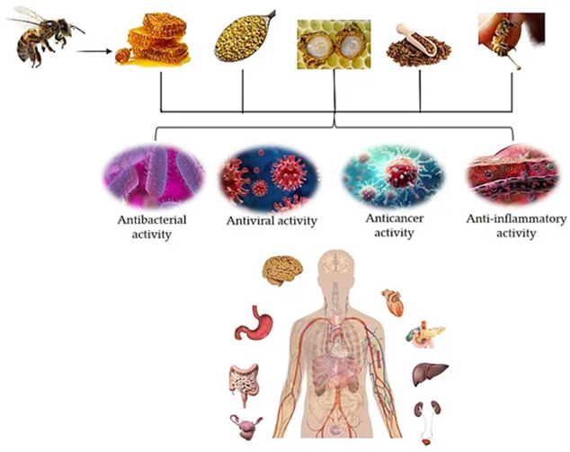

1.2 Bee Products Overview and Constituents
1.2.1 Honey
Honey is a food product produced by honeybees from deposits of plant and flower nectar. Foraging bees gather flower nectar and repeatedly digest and regurgitate it to generate honey. Honey is generally marketed for its nutritive properties, but has been also used since the antiquity as a folk remedy, while in recent times it has been introduced as a pharmaceutical aid and in clinical practice (Molan, 1999). An 80% sugar solution, primarily fructose and glucose, with smaller amounts of sucrose, maltose, and other complex sugars is produced by the stomach’s acidic pH in conjunction with the enzymatic activity of invertase, diastase, and amylase . The kind of honey-collecting bee, the plants from which it is harvested, the climate, the location, and the storage conditions are some of the variables that affect the chemical composition of honey. A better understanding of the health benefits of honey, including its anticancer, antiallergic, antibacterial, antioxidant, antidiabetic, antiparasitic, antiulcer, anti-inflammatory, wound-healing, and cardioprotective qualities, has been made possible by the existence of this varied chemical composition.
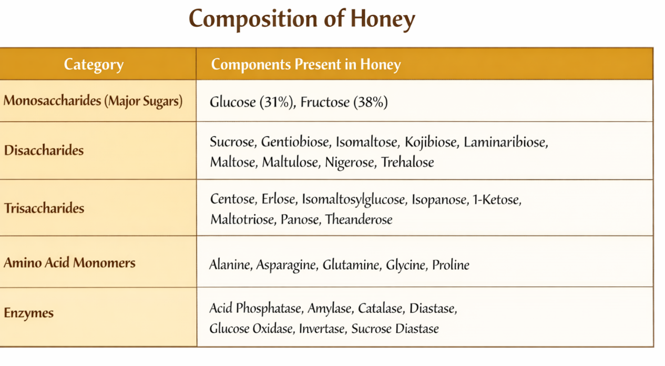
- Antioxidant Activity: It is generally accepted that phenolics are important contributors to the antioxidant capacity of honey. Given that phenolic composition is greatly variable with respect to floral origin, honey is expected to show a wide range of antioxidant power (Gheldof et al., 2002; Petretto et al., 2015).
- Antimicrobial Activity: Honey is known to contrast the growth of various microorganisms. This kind of effect has been a main attractive feature for honey application in clinical medicine, as testified by the development and marketing of γ-irradiated, Manuka medical grade honey. For this honey, a scale of antibacterial activity has been defined, known as Unique Manuka Factor (UMF), representing equivalents of a phenol solution yielding a certain inhibition in a radial diffusion assay on Staphylococcus aureus (Allen et al., 1991).
- Antiparasitic activity: Peptides from Ziziphus sp. honey with molecular masses ranging from 2 to 200 kDa, separated by size-exclusion chromatography, have shown antiprotozoal activity against the intestinal parasite Giardia lamblia (Mohammed et al., 2015).
- Antidiabetic Activity: Fructose is a potential antidiabetic agent, while the presence in honey of a balanced mix of fructose and glucose could play an additional role in this kind of effect, since the two sugars are known to act synergistically in promoting liver glucose metabolism.
- Wound healing: Various data have been collected on honey immunomodulatory properties, which can at least partially explain the ability of promoting wound healing. Even though some authors have argued that honey immunostimulatory effects may derive from bacterial lipopolysaccharide contamination, possible immunomodulatory honey constituents have been isolated.

1.2.2 Royal Jelly
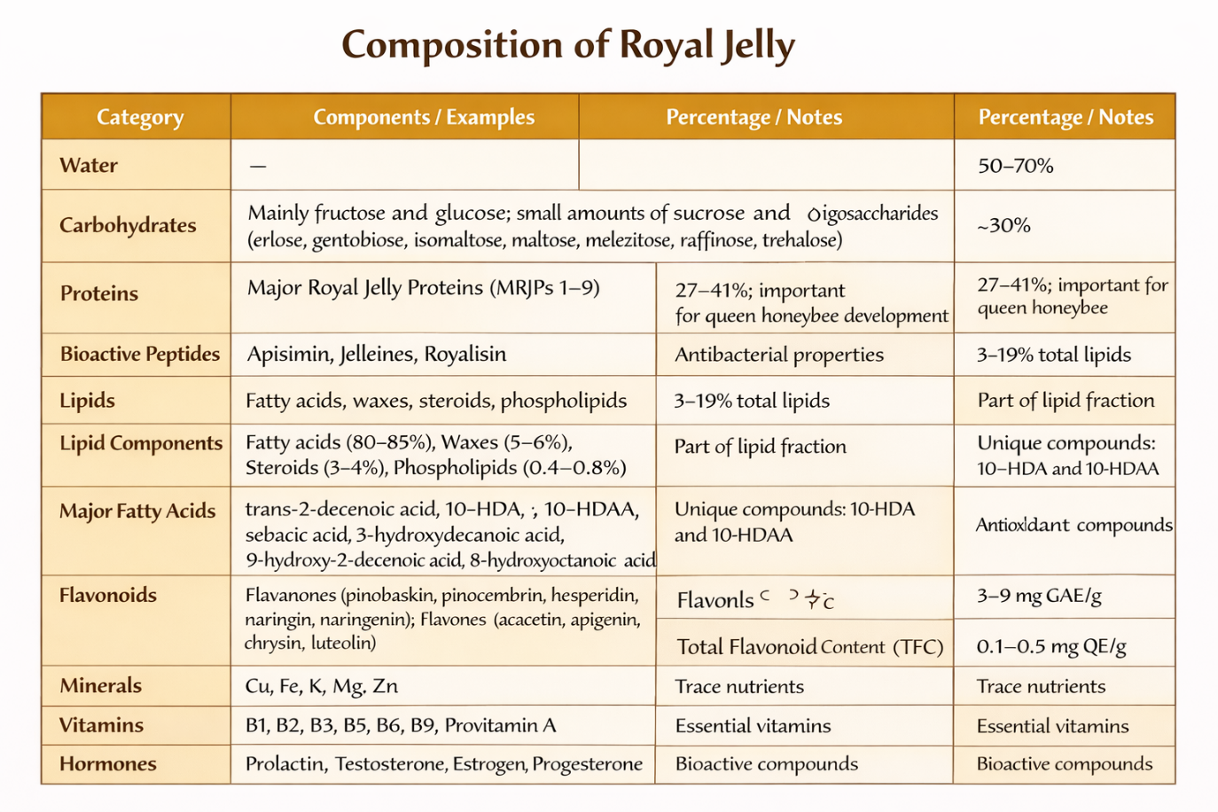
The mandibular and hypopharyngeal glands of worker honeybees produce a thick, white-to-yellow jelly-like fluid known as royal jelly, or bee’s milk It has a pH of 3.1–3.9, a pungent smell, and a sour or sweet taste. It is also mildly soluble in water . A significant part of the nutrition of honeybee larvae is royal jelly. It is only supplied to worker and young drone larvae throughout their maturation phase, and it is fed to queen honeybees for the duration of their life cycle.

- Antioxidant Activity: Small peptides consisting of 2–4 amino acid residues have been reported to possess strong antioxidant activity. Most active ones have tyrosine residues at the C-terminal, allowing hydroxyl radical and H2O2 scavenging activities (Guo et al., 2009).

- Antimicrobial Activity: Antimicrobial assays conducted against the gram-positive S. aureus, S. saprophyticus, and B. subtilis, the gram negative E. coli, E. cloacae, K. pneumoniae, and P. aeruginosa, and the yeast C. albicans have shown that jellein-I and -II have broad-spectrum activity, jellein-III is less active, and jellein-IV has no antimicrobial effect (Fontana et al., 2004).Royal jelly carboxylic acids are known to collectively exert antimicrobial properties against gram-positive, gram-negative bacteria, and fungi. 10-HDA has been identified as a particularly strong antibacterial, especially against B. subtilis, S. aureus, and E. coli (Alreshoodi and Sultanbawa, 2015).
- Anti-inflammatory Activity: In a study on royal jelly potential for digestive trait diseases, 10-HDA has been found to protect rats from experimentally induced gastric ulcer (Fang et al., 1994). A mechanism putatively linked to 10-HDA anti-inflammatory effect is the inhibition of LPS-induced NF-κB activation observed in the murine macrophage cell line RAW264 (Sugiyama et al., 2012).
- Immunomodulatory Activity: Experimental evidence has been collected arguing for royal jelly immunomodulatory properties. both in vitro and in vivo, reconducible to antiallergic properties (Okamoto et al., 2003).Various immunomodulatory activities have been reported for 10-HDA, including reduced T cell proliferation, inhibition of interleukin-12 production by spleen dendritic cells, and block of LPS- and IFN-β-induced NO production in macrophages (Gasic et al., 2007; Sugiyama et al., 2013).
- Metabolic Syndrome Preventing Activity: The royal jelly proteins MRJP-1, MRJP-2, and MRJP-3 have been shown to possess bile acid-binding properties. The most active one is MRJP-1, which in rats has increased fecal bile acids and cholesterol excretion, and has powered hepatic cholesterol catabolism (Kashima et al., 2014).

- Anti-aging Activity: Royal jelly is known to extend the lifespan of honeybees. This property is at least in part due to royalactin, which has been found to induce such effect in other insect species, like Drosophila melanogaster, as well as in non-insect species, like the nematode C. elegans (Detienne et al., 2014). 10-HDA has been shown to increase collagen synthesis and production of the collagen promoting factor, transforming growth factor β1, in human skin fibroblasts. Such an effect is thought to mediate royal jelly skin protection against UVB-induced photoaging (Koya-Miyata et al., 2004; Park et al., 2011).

1.2.3 Propolis
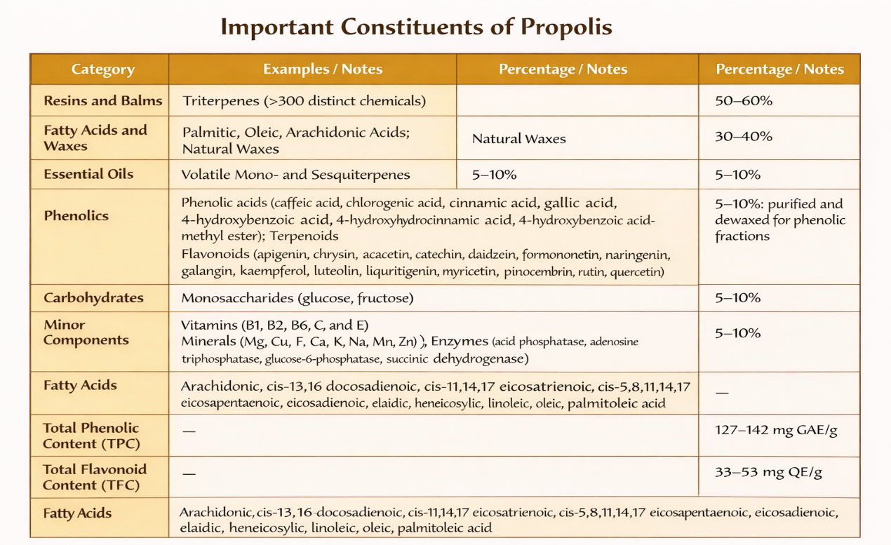
Honeybees generate propolis by combining the exudate from their salivary glands with plant exudate that has been collected from various plant components, including branches, bark, flower buds, leaves, and stems. Propolis is a hard, brittle substance that is lipophilic in nature. It comes in a variety of colors, from green to brown and reddish.When propolis is heated, it becomes soft and sticky and has a pleasant or sweet smell.
- Antimicrobial Activity: The antimicrobial activity of propolis has been demonstrated in clinical, in vivo, and in vitro studies. Propolis possesses antibacterial properties against Gram positive and negative strains, also validated in clinical trials.Propolis antibacterial effects are possibly related to the presence of such flavonoids as galangin, pinocembrin, rutin, quercetin, and naringenin.
- Antiviral Activity: Antiviral properties seem to depend mainly on the presence of CAPE and related compounds. Immunomodulatory Activity
- Anti-inflammatory Activity: Many studies have reported anti-inflammatory properties of propolis, possibly linked to the presence of phenolic acids. CAPE is considered a particularly strong anti-inflammatory constituent.
- Wound Healing and Skin Protection:Animal models and clinical trials have shown the healing effect of propolis on diabetic foot ulcers and other problematic tissue injuries
- Anticancer Activity: A very large number of in vitro and pre-clinical studies on propolis anticancer effects are available, while only few clinical studies have been conducted and their results are controversial.
1.2.4 Bee Venom
A gland in the bees’ abdominal cavity secretes apitoxin, or bee venom. Bees often use this clear, acidic liquid with no smell as a weapon in their defense against potential predators. Melittin, a major component of bee venom, is also present, as are apamin, adolapin, and mast cell degranulating peptide.
Bee venom and bee-derived toxins have been utilized in traditional medicine to treat chronic inflammatory illnesses because of their many effects, including their anti-arthritic, anti-cancer, and analgesic properties.
A variety of ailments, including autoimmune disorders (rheumatoid arthritis, psoriasis, and so forth), neurological disorders, chronic inflammations, pain, skin conditions, and microbiological infections may be treated by injecting bee venom

1.2.4 Pollen
Worker honeybees generate bee pollen, which serves as the larvae’s main source of nutrition [64,65]. Bee pollen is the result of combining components of honeybee salivary enzymes with floral nectar and flower pollen. The types of plants, bee activity, and meteorological factors all affect the chemical composition of bee pollen .

- Antioxidant Activity : Protects cells from oxidative damage by neutralizing free radicals. Due to phenolic acids (vanillic, gallic, protocatechuic, p-coumaric) and flavonoids (quercetin, rutin, luteolin, kaempferol) which scavenge reactive oxygen species (ROS).
- Antimicrobial Activity: Helps kill or inhibit bacteria, fungi, and yeasts. Caused by glucose oxidase enzyme and phenolic compounds & flavonoids that damage microbial cell membranes.
- Anti-inflammatory Activity: Reduces swelling and inflammation in tissues. Flavonoids, phenolic acids, phytosterols, and compounds like anethole inhibit the NF-κB inflammatory pathway.
- Anticancer Activity: May help destroy cancer cells and prevent tumor growth. Antioxidant and antimutagenic compounds induce apoptosis and increase TNF-α secretion, which kills cancer cells.
- Antiatherosclerotic & Antidiabetic Activity: Helps reduce cholesterol, protect the heart, and control blood sugar.Presence of unsaturated fatty acids (ω-3, α-linolenic acid), phytosterols, steroids, alkaloids, and flavonoids which regulate lipid metabolism and glucose levels.
- Immunomodulatory Activity: Strengthens and regulates the immune system and reduces allergic reactions. Flavonoids, steroids, and volatile oils inhibit IgE binding, histamine release, and mast cell degranulation.
- Nutritional Properties: Acts as a nutrient-rich supplement improving energy, immunity, and recovery. Contains amino acids, vitamins (tocopherol, niacin, thiamine, biotin, folic acid), minerals, polyphenols, carotenoids, and phytosterols.
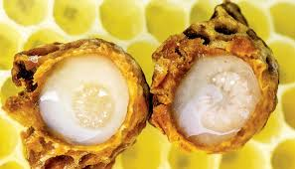
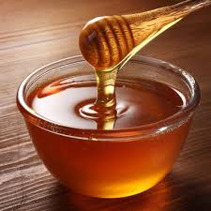
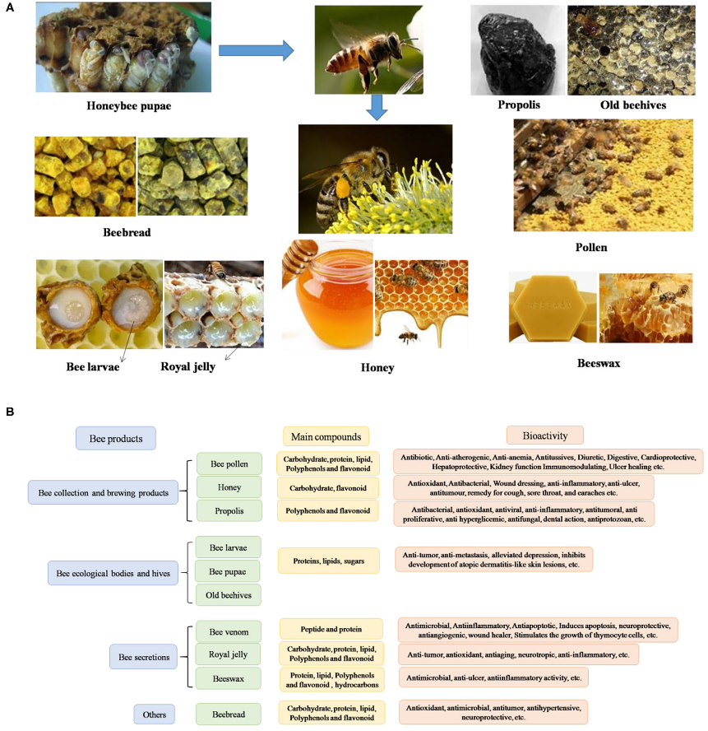
Royal Jelly
Honey
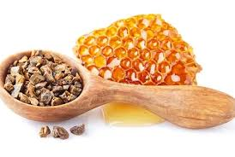
Propolis

Health benefits of beehive products
1.3 Conclusion
Bee hive products are highly valuable because of their rich chemical composition and diverse biological activities. Scientific studies have shown that substances such as honey, royal jelly, propolis, and bee pollen contain numerous bioactive compounds including phenolics, flavonoids, enzymes, vitamins, and minerals that contribute to their nutraceutical and pharmacological properties. These compounds provide various health benefits such as antioxidant, antimicrobial, anti-inflammatory, and immunomodulatory effects. Therefore, further research and wider application of apitherapy could be beneficial in developing natural therapeutic alternatives, especially in addressing challenges like drug resistance and improving human.

----------------------------------------------------------------------------------

